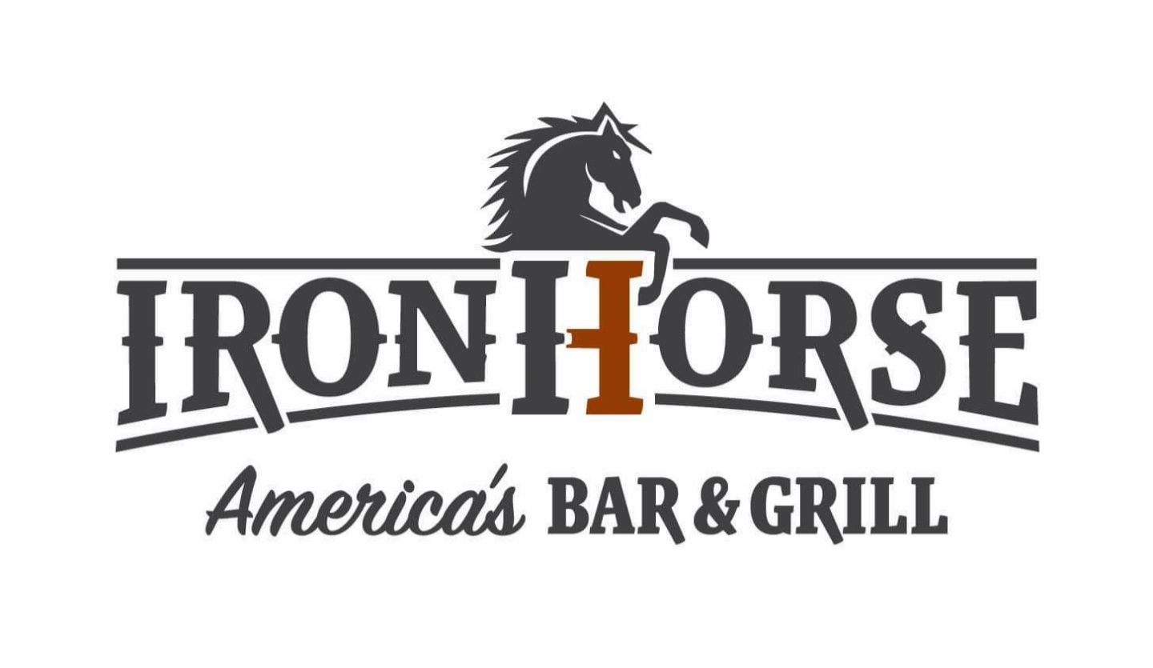
Gluten Free Options

5317 W. 151st Street Leawood KS 66224 - www.ironhorsegrillbar.com
913.701.6943 – for curbside, or carryout
Starters:
All appetizers are made from scratch in house:
- Buffalo Chicken Dip - ancho grilled chicken mixed in cream cheese with buffalo sauce, garlic, and scallions. Served with sub grilled pita for XTRA fresh veggie and fresh veggie – 11

- Bacon Wrapped Shrimp - we take our 16/20 jumbo shrimp and wrap them in applewood smoked bacon, deep fry till crispy then finish with a drizzle of our chimichurri sauce. Served with freshly made guacamole and garnished with squeeze of lime this dish is gluten free, however the bacon wrapped shrimp is fried in oil that other menu items with gluten have been cooked in – 15

- Whole Jumbo Chicken Wings - “whole” jumbo wings with a kick, tossed in buffalo sauce or BBQ sauce and a side of blue cheese dressing served with celery and carrot; must be charred option this dish is gluten free, however the bacon wrapped shrimp is fried in oil that other menu items with gluten have been cooked in -13

- Black Bean Hummus - served with sides of carrots, celery, and sub grilled pita for extra veggies. Then we garnish with freshly cut cilantro and lime -11

- BAM! BAM! Hog Wings - 4oz pork shank wings, fried to crispy perfection, tossed with a choice of buffalo sauce served with bleu cheese dressing or a spicy BBQ sauce and a side of carrots and celery this dish is gluten free, however the bacon wrapped shrimp is fried in oil that other menu items with gluten have been cooked in - 15

Salads:
- “The Cobb”- a blend of fresh cut romaine and red leaf lettuce, red onion, applewood smoked bacon, avocado, tomato, a fresh boiled egg, ancho grilled chicken and sliced scallions with drizzled avocado crème - 14

- Southwest Salad - fresh cut romaine hearts, diced tomato, scallions, roasted jalapeno, black beans, shredded cheddar cheese and avocado finished with ancho grilled chicken then tossed in our avocado crème and remove tri-colored tortilla strips. garnished with cilantro and lime wedge. The perfect salad - 14

- Caesar Salad - fresh grilled romaine, remove in- house made croutons, freshly shaved parmesan served with homemade Caesar dressing - 11
  - Add grilled chicken or salmon for – 4

Chili and Soups:
- “Iron Horse” Burnt End Chili - a western style smoky chili made from burnt ends cut from our in-house smoke brisket with fresh herbs, roasted chilies, spices, and tomatoes in a rich beef base topped with sour cream, shredded cheddar cheese and scallions, remove side of tortilla chips – 11

Sandwiches: All sandwiches come with freshly cut fries. (sub onion rings for - 3)

- Iron Horse Burger - 8oz of fresh never frozen Angus ground chuck, cheddar cheese, whiskey bacon marmalade (chefs’ secret recipe), arugula, spicy BBQ sauce and fried egg on a sub gluten free bun for grilled potato bun – 16

- The Great American Burger - a half pound of fresh, never frozen, Angus ground chuck, choice of cheese (pepper jack, swiss, cheddar, American or Havarti) lettuce, fresh ripe tomato, red onion, and pickles on a sub gluten free bun for grilled potato bun - 15

- Open Faced Beef Melt - slow smoked brisket, caramelized onions, sautéed mushrooms, swiss cheese on remove Texas toast or sub for toasted gluten free bun, served with a side of au jus. – 16

- Spicy Bacon Ranch Chicken Sandwich - grilled rosemary chicken, topped with jalapeno ranch, crisp lettuce, tomato, red onion, strips of applewood bacon & pepper jack cheese on a toasted gluten free bun - 14
Entrees:
- Blackened Cajun Shrimp and Salmon - Grilled Blackened Salmon with Shrimp Sauteed in-house Cajun seasoning served over a bed of cilantro lime rice with Cajun glazed carrots - 22

- Beef Flat “Iron Horse” - sliced 8oz chimichurri marinated grilled flat iron Angus steak topped with a chimichurri drizzle served swith au gratin potatoes and roasted root vegetables - 23

- Grilled Ribeye - 14oz of choice Angus beef ribeye steak seasoned to perfection served with au gratin potatoes and roasted root vegetables - 33

- Grilled Salmon - hand cut fresh grilled Atlantic salmon with lemon dill butter, freshly made creamy mashed potatoes and roasted root vegetables - 18

- Iron Horse Mac - cavatappi pasta tossed with our house smoked brisket, with smoked gouda, topped with a remove parmesan breading, bacon, and toasted to a nice golden brown, served with glazed carrots – 17

- Smoked Brisket - sliced slow smoked brisket, creamy mashed potatoes, Iron Horse rustic kickin BBQ sauce, and glazed carrots. - 19

- “The Healthy Horse" Vegetarian Bowl - cilantro rice topped with roasted corn, jalapeno, diced tomato, red onion, black beans, avocado drizzled with cilantro oil. Served with lime. - 17
Sides:
- Hand Cut Rosemary Truffle Fries this dish is gluten free, however the bacon wrapped shrimp is fried in oil that other menu items with gluten have been cooked in – 5
- Creamy hand smashed Yukon Gold mashed potato - 5
- Thin sliced Au Gratin Potato layered with a blend shredded cheese, cheese sauce, bacon, and sliced white onions garnished with parsley - 5
- Roasted Root Vegetables - 4
- Honey Glazed Carrots garnished with parsley - 4
- Creamy Gouda Mac-N’-Cheese topped with a remove parmesan breading and toasted to a nice golden brown - 5
- Fresh Fruit Cup - 4
Kids Options: All kid options come with any choice of side
- 4oz American Burger fresh never frozen Angus ground chuck, choice of cheese sub gluten free bun (American or cheddar) - 6
- ½ Portion of Gouda Mac N’ Cheese remove parmesan breeding - 6

