

T A R D O R 2 0 2 6
Wine Program: Paco Calza & Jerry Argüelles
Cocktails: Javier Ruano & Jerry Argüelles

GINTONICS & SPECIALTY COCKTAILS

BCN Gin & Tonic 16
Hendrick's, Fever-Tree Premium Tonic, Juniper Berries & Cucumber

Green Apple Gin & Tonic 20
Nordes, Fever-Tree Premium Tonic, Verjus, Green Apple & Cardamom Bitters

Piquillo Gin & Tonic 20
Drumshanbo Gunpowder Irish Gin, Polara ‘53 Tonic, Piquillo Pepper-Raspberry Shrub
& Ceniza Oil

Granada Gin & Tonic 18
Three Cuts, Fever-Tree Premium Tonic, Pomegranate, English Mint & Lime

Oeste Gin & Tonic 19
Wild June, Fever-Tree Premium Tonic, Rosemary, Grapefruit, Saline & Lucky Sorrel

Peppercorn Gin & Tonic 18
No. 3, Fever-Tree Mediterranean Tonic, Pickled Peppercorn & Thyme

Lavender Gin & Tonic 22
The Botanist Gin, Fever-Tree Elderflower Tonic & Fresh Lavender

Guava Gin & Tonic 20
Hawthorn’s, Fever-Tree Premium Tonic, Guava, Cayenne, Lime, Matcha
& Smoked Chili Bitters

The Ultimate Gin & Tonic 26
Monkey 47, Tonic Ice Cube, Polara ‘53 Tonic, Pink Peppercorns & Lime

Valenciano Gin & Tonic 18
Coffee infused Gin Raw, Polara ’53 Tonic & Torres Magdala Orange Liqueur

Ginger-Lime Gin & Tonic 16
Tanqueray Rangpur, Mediterranean Tonic, Ginger, Lime, Cardamom & Star Anise

Jardín Vodka & Tonic 18
Una Vodka, Fever-Tree Elderflower Tonic, Honey, Lemon, & Lavender

Las Ramblas 17
Bulleit Bourbon, Calvados, Date, Honey & Chocolate Bitters

Sangria 16
Spanish Wine, Brandy, Fresh Citrus, Seasonal Fruit

SPANISH VERMUT
Spanish Vermouth or Vermut is recommended as an aperitif,
served on the rocks with an olive and an orange slice.

Astobiza, Amurrio 15

Casals, Penedés 14

Lustau Blanco, Jerez De La Frontera 14

Lustau Rosé, Jerez De La Frontera 14

Lustau Rojo, Jerez De La Frontera 14

Gonzalez Byass “La Copa Rojo” Jerez De La Frontera 14

Valdespino “Vermouth Origen” Jerez De La Frontera 14

BOTTLED BEER

Estrella Damm 9
Pilsner Lager

Estrella Galicia 8
Lager

Estrella Galicia 1906 “Reserva Especial” 9
Dark Amber Lager

Estrella Galicia 0,0 7
Non-Alcoholic Lager

SIN ALCOHOL & TONICS

BCN Zero 14
Seedlip Garden, Fever-Tree Indian Tonic, Cucumber & Lemon Twist

Piquillo Zero 14
Veridosché, Polara ‘53 Tonic, Piquillo Pepper-Raspberry Shrub & Ceniza Oil

Elderflower 12
Grapefruit Juice, Fever-Tree Elderflower Tonic & Lavender

Spiced Apple 14
Seedlip Garden, Fever-Tree Elderflower Tonic, Red Apple, Cranberry & Lemon
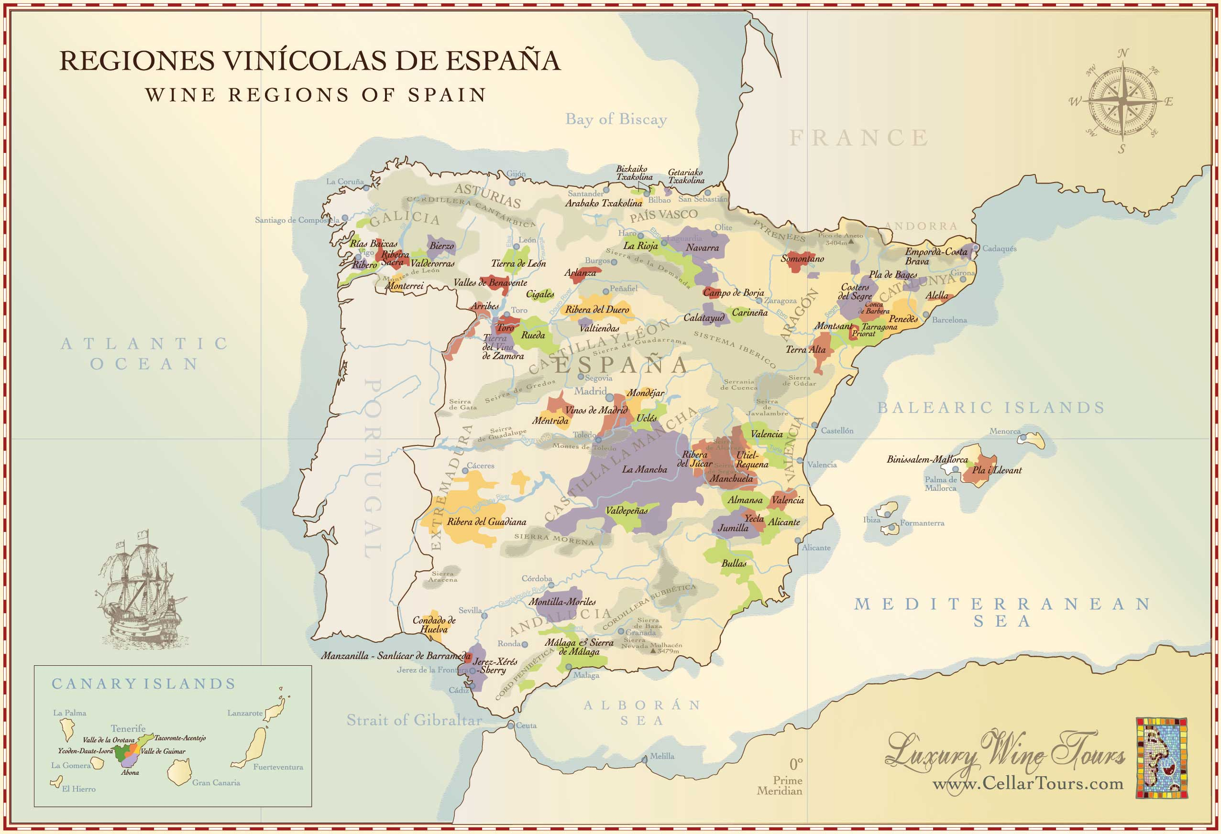

WINES BY THE GLASS

S P A R K L I N G

2023 Raventós i Blanc “de Nit” Rosé Extra Brut, Conca del Riu Anoia 22
Macabeu, Xarel·lo, Parellada & Monastrell
2019 Gramona “Imperial”, Brut, DO Penedés 25
Xarel·lo, Macabeu, Parellada & Chardonnay

W H I T E

2025 Ameztoi Txakoli, DO Getariako Txakolina 15
Hondarrabi Zuri
2022 Gramona “Gessamí”, DO Penedés 16
Muscat, Sauvignon Blanc, Gewürztraminer
2024 Palacio de Bornos “La Caprichosa”, DO Rueda 15
Verdejo
2024 Eccocivi “Montrodó”, Sant Martí Vell 17
Chardonnay, Garnacha Blanca & Viognier
2025 Paco & Lola, DO Rías Baixas 18
Albariño
2025 Emilio Moro “Polvorete”, DO Bierzo 20
Godello
2024 Avancia “JO”, DO Valdeorras 25
Godello

R O S É

2025 Muga “Rosado”, DOCa Rioja 15
Garnacha & Viura

R E D

2024 Guimaro, DO Ribeira Sacra 18
Mencía
2020 Beronia Reserva, DOCa Rioja 20
Tempranillo, Graciano & Mazuelo
2019 Eccocivi “Can Noves”, Sant Martí Vell 20
Cabernet Franc, Merlot & Cabernet Sauvignon
2023 Familia Torres “Secret Del Priorat”, DOQ Priorat 22
Garnacha, Cariñena, Cabernet Sauvignon, Merlot & Syrah
2021 Cepa 21, DO Ribera del Duero 25
Tempranillo
2021 Abadia Retuerta “Selección Especial”, Vino de la Tierra de Castilla y León 28
Tempranillo, Cabernet Sauvignon, Syrah, Merlot, Petite Verdot & Garnacha
2023 El Nido “Clio”, DO Jumilla 30
Monastrell & Cabernet Sauvignon
-

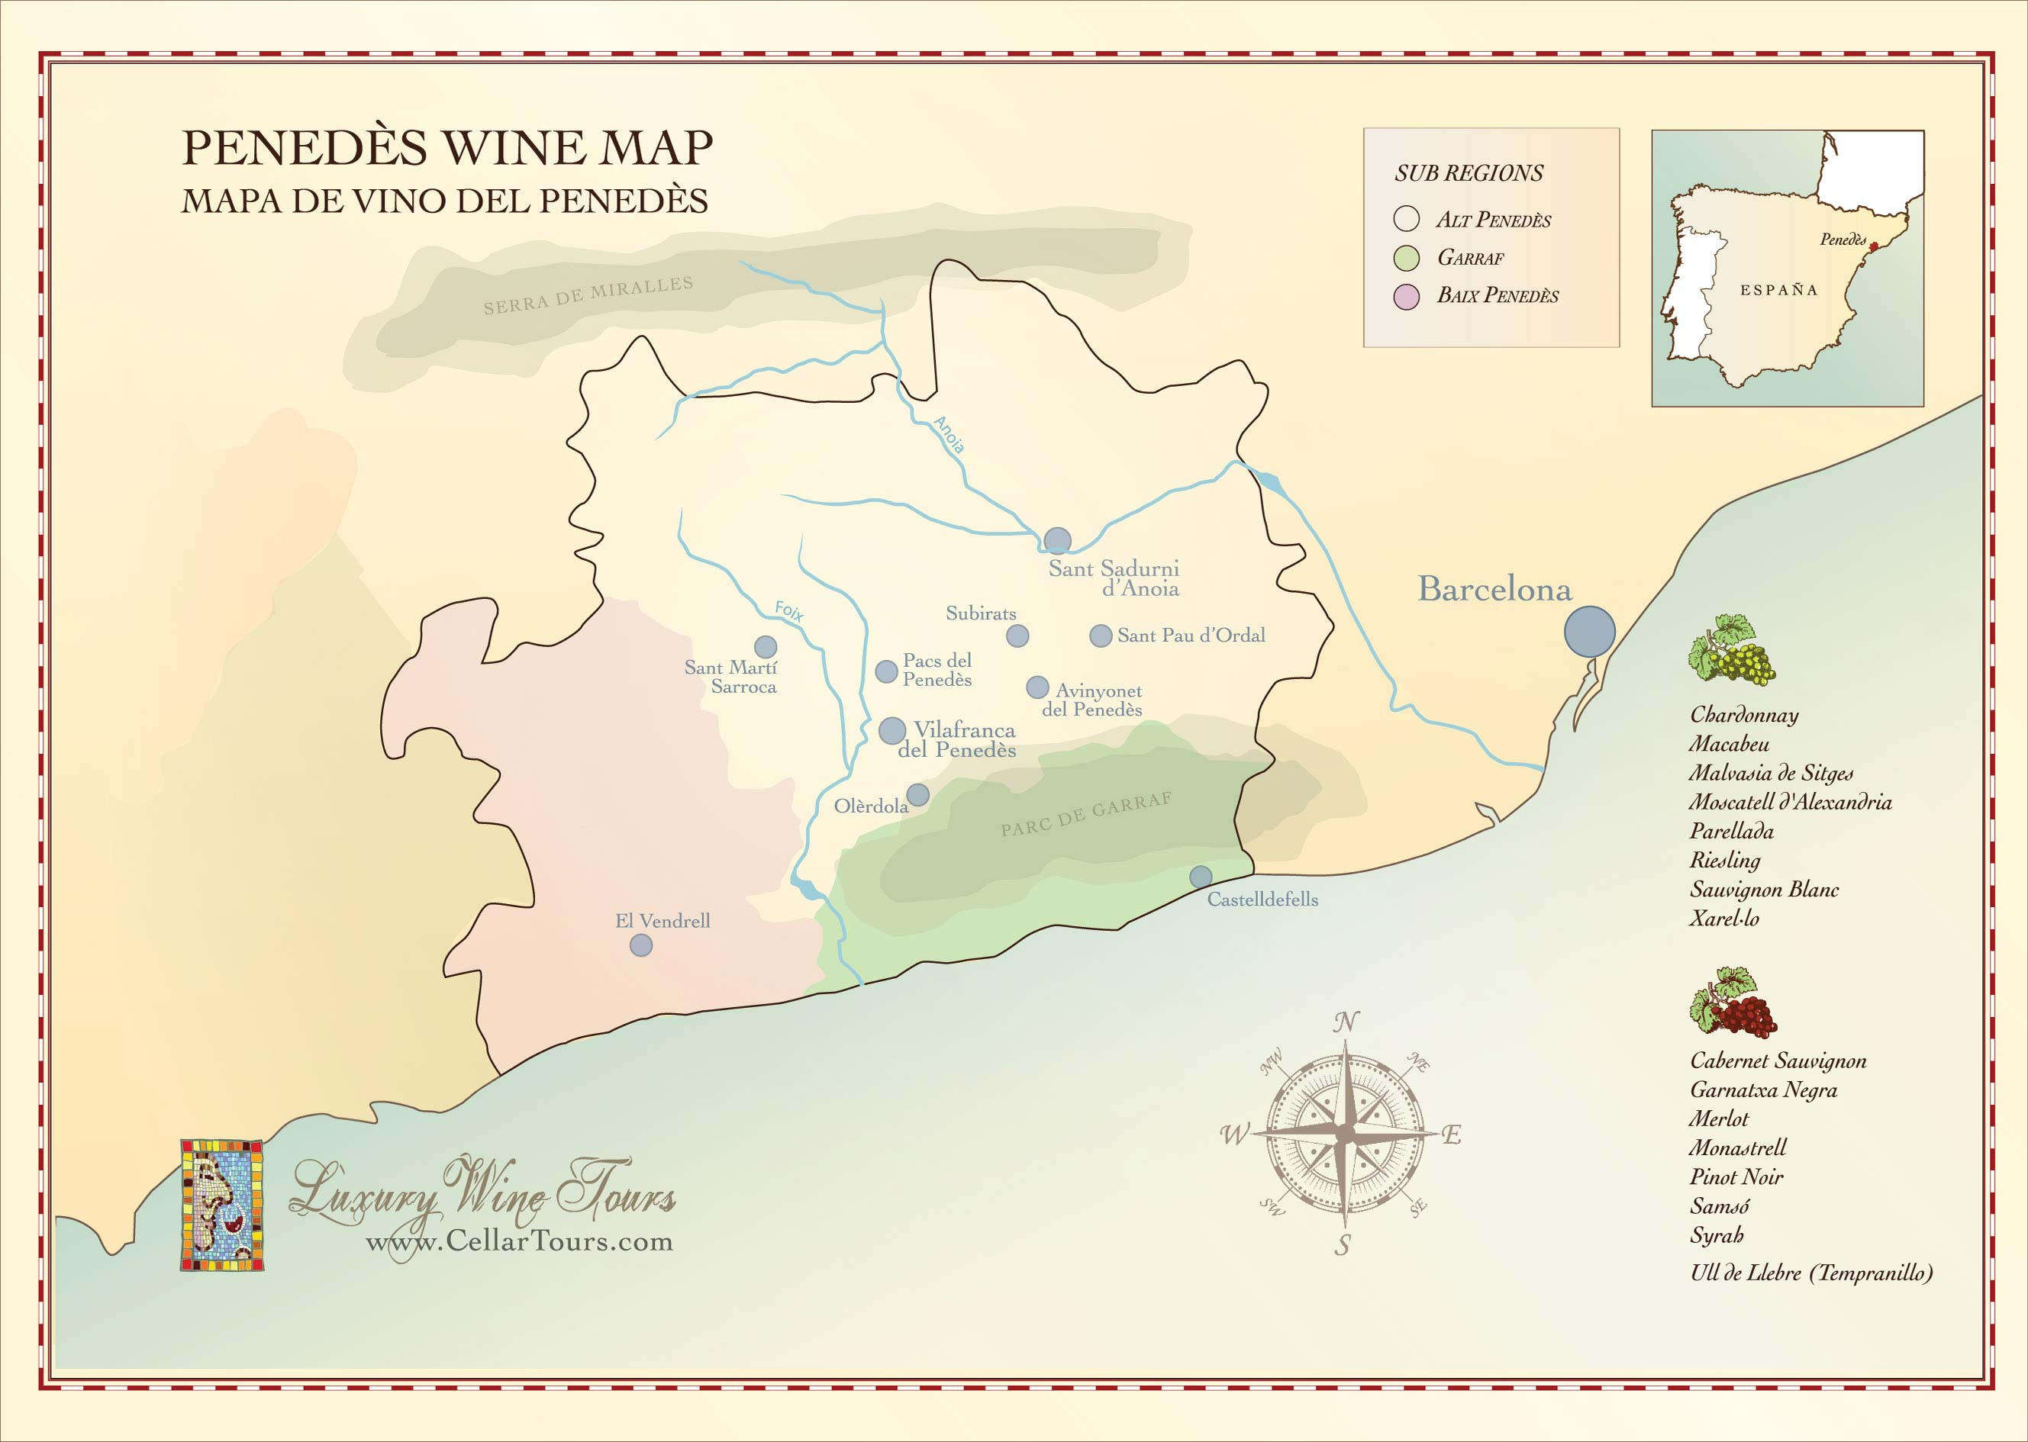

SPARKLING

CORPINNAT

CORPINNAT is a collective European Union brand established with the aim of distinguishing great sparkling wines made in the heart of the Penedés from 100% organic grapes harvested by hand and entirely vinified on the premises of the winery.

2019 Gramona “Imperial”, Brut 100
- Xarel·lo, Macabeu, Parellada & Chardonnay -
In the mouth it shows the very fine and creamy bubbles typical of his sparkling wine. It is ample and at the same time lively and refreshing. Aromas of baked apples and pastries return.

2019 Recaredo “Terrers”, Brut Nature 100
- Xarel·lo, Macabeu & Parellada -
A harmonious Cava, dry and lacy in texture, with a pleasing creaminess to the well-meshed flavors of white raspberry, biscuit, and lemon parfait, underscored by a streak of smoky mineral.

2015 Gramona “III Lustros”, Brut Nature 112
- Xarel·lo & Macabeu -
The entry on the palate is powerful, with great structure. The very fine bubbles melt into the wine and provide a velvety texture. It has great freshness and verticality, with a finish full of mineral sensations.

SPARKLING CONTINUED…

CONCA DEL RIU ANOIA

Conca del Riu Anoia forms a very small geographical area surrounding the Anoia River valley between the Anoia and Foix River in Eastern Penedes. The Raventos family decided in 2012 to create their own D.O. and create specific quality-oriented guidelines.

2022 Raventós i Blanc “De La Finca", Brut Nature 75
- Xarel·lo, Macabeo & Parellada -
A minerally sparkler, with a chalky underpinning and a fresh, lacy texture, this shows a subtle range of Asian pear and white cherry fruit as well as hints of white blossom, smoke and preserved lemon.

2023 Raventós i Blanc "de Nit" Rosé, Extra Brut 88
- Macabeo, Parellada, Xarel·lo & Monastrell -
This pale pink sparkling rosé is firmed by rapier-like acidity, and is lightly chalky in texture, offering a subtle range of white raspberry, lemon thyme and blanched almond, with accents of graphite and spice on the finish.

2017 Raventós i Blanc “Manuel Raventós Negra", Brut Nature 180
- Xarel·lo, Parellada & Macabeu -
Elegant and harmonious, with toast and oyster shell elements edging the peach, white cherry and coffee flavors that are streamlined, harmonious and nicely integrated.

2014 Pepe Raventós “Mas Del Serral", Brut Nature 300
- Xarel·lo, & Bastard Negre -
Extreme elegance on the nose with aromas of dry toast, apricot and peach. Intense notes of baked apple and quince, honey and sherry are enriched with salty nuts and bakery flavours. On the palate, this wine is complex and fresh with a marked minerality.

SPARKLING CONTINUED…

DO CAVA

The origins of Cava lie in the winemaking area of Penedés, especially in the town of San Sadurní d’Anoia and its surroundings, which has earned the title of Cava capital. However, for historical reasons, Cava can also be made in certain other towns and regions.

2013 Roger Goulart “The Roger” Gran Reserva, Brut Nature 120
- Pinot Noir & Chardonnay -
On the nose it shows clear notes of aging with predominance of aromas of dried fruit, toast, ripe stone fruit, dried flowers and brioche. In the mouth it is quite voluminous, with lively acidity present and crisp. Very well integrated with a long and persistent finish, leaving a delicate creamy bouquet and notes of aging on yeast.

2022 Aldonza Reserva, Brut 130
- Xarel·lo, Macabeo, & Chardonnay -
Pale yellow colour and strong bubble formation with the bubbles forming a crown. Stands out because of its scent of crianza, ripe fruit and flowers. In the mouth it is round, harmonious, dry and long.

2016 Agustí Torelló Mata “Kripta” Gran Reserva, Brut Nature 200
- Macabeo, Parellada & Xarel·lo -
A clean and crisp bouquet reminiscent of hazelnuts, fresh citrus, and ripe fruits – pear and yellow apple - with notes of lightly buttered toast, vanilla spice, and truffle. Very elegant and delicate with a lingering, clean finish.

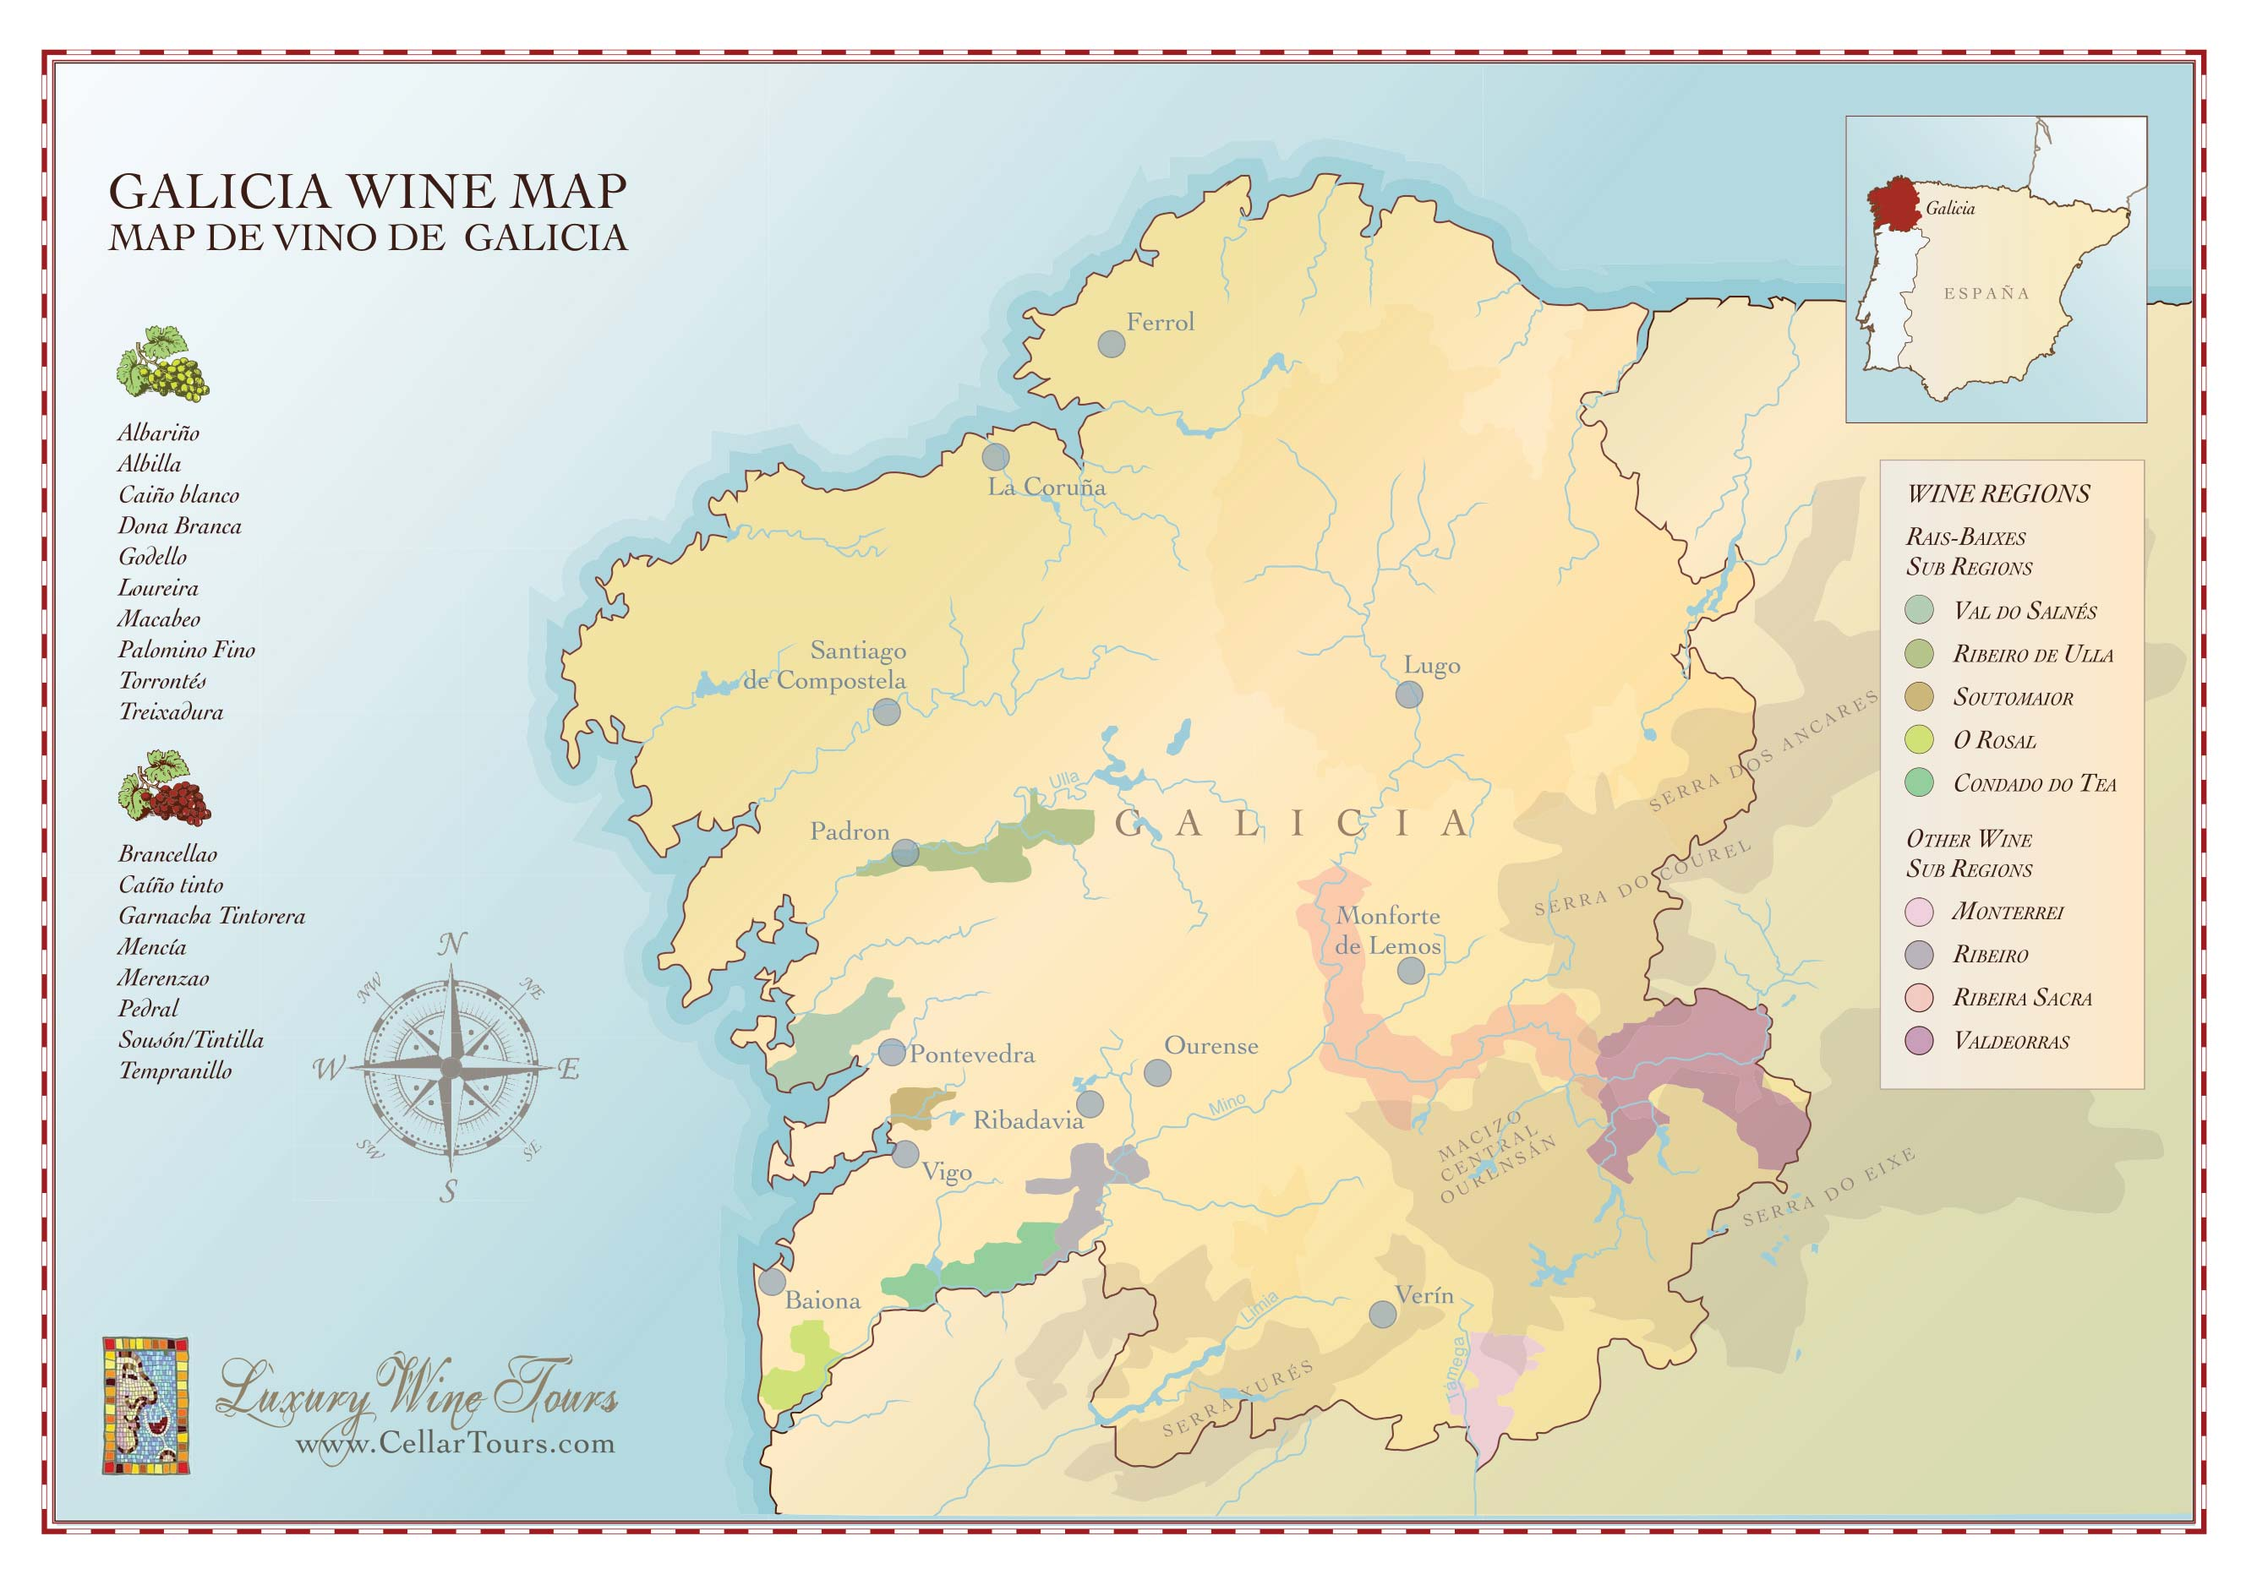

WHITE

2025 Ameztoi Txakoli, DO Getariako Txakolina 60
- Hondarrabi Zuri -
The wine is crisp and refreshing, with bright acidity and distinctive citrus, green apple, and slightly saline notes that reflect its seaside terroir.

2024 Palacio de Bornos “La Caprichosa”, DO Rueda 60
- Verdejo –
Bright straw yellow colour, with green glints. Intense and complex aroma, with notes of ripe white fruit and mineral hints. Fresh and generous in mouth, with volume, mild and lingering.

2025 Paco & Lola, DO Rías Baixas 72
- Albariño –
Straw yellow with greenish, bright, and clear tones. Medium-high, citric notes and white flowers, acacia, and orange blossom, with a sweet tropical background, intense aroma of lychees. Fresh, citric, intense, and fruity mouth. Elegant, slightly bitter finish.

2023 Anna Espelt “Pla de Gates”, DO Empordà 80
- Garnacha Blanca & Garnacha Gris –
This delicious white carries the balsam top notes of the Mediterranean coast of rosemary and juniper, a generous mid-palate driven by saline-tinged stone fruits, apple, and a mouthwateringly refreshing finish.

2025 Emilio Moro “Polvorete”, DO Bierzo 80
- Godello –
A bright and aromatic wine, displaying clear notes of green apple, pear, and white flowers that lead into a fresh, lively palate. On the mouth, it is light, balanced, and highly approachable, with a well-judged acidity that enhances its fruit-forward character and a smooth texture that adds breadth without losing vibrancy.

2024 Avancia “JO”, DO Valdeorras 100
- Godello –
A graceful, creamy white that expands on the palate, with fruit flavors of pineapple and baked peach enriched by accents of lemon-infused pastry cream, graham cracker and pickled ginger. Medium-bodied and lively, with a lingering finish of spice and fleur de sel.

2022 Emilio Moro "La Revelía", DO Bierzo 100
- Godello -
An intense straw yellow wine, clean and bright. On the nose, we find complex notes with hints of ripe stone fruit and dried flowers. On the palate, the wine has volume and length thanks to its careful ageing in French oak barrels. When swallowed, it is unctuous and the acidity and minerality of the grape variety are evident.

2024 DO Ferreiro, DO Rías Baixas 100
– Albariño -
Light-bodied, it offers sublime lemony and tangerine flavor and a grippy texture kept fresh and nervy from the lovely acidity.

WHITE CONTINUED…

2020 Vega Sicilia Oremus “Mandolás”, Tokaj, Hungary 110
- Furmint -
A sleek, balanced white, with bright acidity enlivening pretty aromas and flavors of almond blossom, white cherry and lemon peel. A streak of salinity races on the finish.

2024 Palacio de Bornos “Colección de Familia” Gran Vino De Rueda 120
– Verdejo -
Structured, unctuous, and silky on the mouthfeel. It displays crunchy pear, green apple, quince, and guava layered with a distinctive salty, mineral grip on the mid-palate.

2022 Granbazán “Limousin”, DO Rías Baixas 120
– Albariño -
On the nose, it captivates with an aroma of ripe white fruits, such as apples and pears, perfectly balanced with sweet spice notes and a subtle hint of freshly baked pastry. On the palate, it is juicy and silky, reaffirming its fruity nature with a spicy touch that adds depth and complexity to each sip.

2022 Pazo Barrantes Gran Vino, DO Rías Baixas 120
– Albariño -
This white has a smooth, luxurious texture, with lime, honey cream, white blossom and tangerine flavors that are matched with a hint of toast and ample spice elements. Mouthwatering acidity is well-integrated, with a long, lingering finish.

2023 Abadía Retuerta “L’Domaine”, Vino de la Tierra de Castilla y León 140
- Sauvignon Blanc & Verdejo -
Full of intense aromas of honey, ripe peach, ginger and floral notes open up onto a soft, mouth-filling palate with exotic citrus, grapefruit and apple fruit flavours.

2025 Avancia “Nobleza”, DO Valdeorras 140
- Godello -
A light and elegant white, with vibrant acidity buoying flavors of pink grapefruit sorbet and baked melon, grated ginger, white blossoms, and honeycomb. Delivers spice and mineral details that echo on the lasting finish.

2022 Clos Mogador “Nelin”, DOQ Priorat 145
– Garnacha Blanca -
Powerful, unctuous, and full-bodied with a refreshing citrus tip and notes of vine peaches, exotic fruits, and wildflowers

2022 Familia Torres “Varietat Recuperada No. 23”, DO Penedés 150
– Forcada -
Forcada, an ancestral varietal, was rediscovered by Familia Torres in the northwestern part of DO Penedès, in the foothills of the Roca Forcada Mountain, near Vall de Bianya. Aromas of pear skin, white peach and chamomile, along with a touch of stoniness. A fresh and intensely aromatic wine with beautiful floral notes.

WHITE CONTINUED…

2021 Familia Torres "Milmanda", DO Conca de Barbera 180
– Chardonnay -
An engaging, creamy texture carries the ripe apple, spice and white peach flavors of this medium-bodied white. A mouthwatering acidity gives this focus, with a floral touch on the finish.

2024 DO Ferreiro “Cepas Vellas”, DO Rías Baixas 180
– Albariño -
Textured, rich and ever evolving, this wine has a lively acidity and an intricately detailed texture, full of nuance and finesse. Lively notes of bitter herbs, citrus, passion fruit, aniseed and cream. Long, smokey-mineral finish with a remarkable longitude.

2022 Roda I “Blanco”, DOCa Rioja 200
– Viura, Malvasia & Garnacha Blanca -
Features an intense nose of ripe white peach, quince, and grapefruit, layered with elderflower, toasted almond, vanilla, and distinct limestone-mineral tension. The palate is broad, creamy, and unctuous yet balanced by sharp, well-honed acidity and a subtle, refreshing bitter-citrus finish

2024/2025 Pinea, Korde “El Mochuelo”, DO Ribera del Duero 240
– Albillo Mayor-
Layered and expressive, showing aromas of white blossom, preserved citrus and delicate saline minerality that lead to a palate of remarkable depth and precision.

2017 Remelluri “Blanco”, DOCa Rioja 250
– Viura, Garnacha Blanca, & Malvasia -
Super white with dried-apple, peach, stone and mineral aromas and flavors. It’s full-bodied with layers of complex, ripe fruit and bright acidity. Undertones of cream and nougat. Seamless texture. Rioja’s answer to grand cru Burgundy. From organically grown grapes.

ROSÉ

2025 Muga “Rosado”, DOCa Rioja 60
- Garnacha & Viura -
A very intense, complex nose, with an initial sensation of peaches, apricots and white blossom. On the palate, it is very well balanced with the acidity integrated with the sensation of volume in the mouth and a very long finish which brings back the reminders of stone fruit and some citrus nuances.

VEGA-SICILIA
Few wines have a history as distinguished as that of Vega Sicilia. Founded in the 1860’s, its top cuvée, Unico, was Spain’s first great wine and until recent decades the only Spanish wine collected and coveted throughout the world.

2021 Pintia, DO Toro 220
- Tinta de Toro -
The independent member of the Vega Sicilia family. Pintia is young, intense and ground-breaking in nature. Proud of its origin, it has managed to reinterpret the Vega Sicilia culture in an innovative, brave and daring manner, at the head of the emergence of a new generation of Toro wines.

2020 Benjamin de Rothschild & Vega Sicilia “Macán”, DOCa Rioja 250
2020 Benjamin de Rothschild & Vega Sicilia “Macán”, DOCa Rioja 1.5L 500
- Tempranillo -
Macán is a modern yet personal view of the high profile and maximum quality vineyard in the Rioja DOC. It promises finesse, elegance, complexity and strength. Macán is the winery´s flagship, a project started by Tempos Vega Sicilia and the Compagnie Vinicole Baron Edmond de Rothschild in 2004.

2021 Alion, DO Ribera del Duero 290
2018 Alion, DO Ribera del Duero 3L 1200
- Tempranillo -
Alión, whose name refers to the area of León where the patriarch of the Álvarez family was born, showcases the virtues of the terroirs, climate and varieties typical of Ribera del Duero.

2020 Valbuena No. 5, DO Ribera del Duero 470
- Tempranillo & Merlot-
Valbuena is the purest expression of the Tinto Fino in Vega Sicilia. Tinto Fino is clearly the predominant wine in the assemblage of the varieties that make up this magnificent wine. The other variety used is Merlot, which is added to a greater or lesser extent depending on the vintage.

VEGA-SICILIA CONTINUED…

1990 Unico 2500
2004 Unico 2000
2005 Unico 1700
2011 Unico 1400
2013 Unico 1.5L 2200
2015 Unico 1100
- Tempranillo & Cabernet Sauvignon -
Patriarch and precursor of a line of exceptional wines, forged over time, whose durability distinguishes and gives them a special character.
With an inimitable, firm and solid style, it has been able to create a unique and timeless taste. A world-renowned icon that thanks to endeavors, perseverance and discretion has carved the story of Vega-Sicilia
It is the Vega Sicilia flagship. The qualities of the Tempranillo and Cabernet Sauvignon in different proportions are assembled to perfection in this wine. Each provides a differentiating factor that makes the wine great in every vintage.

VEGA-SICILIA
"UNICO"
SELECCIÓN RESERVA ESPECIAL

NV R22 Vega-Sicilia 2008 - 2010 - 2011 “Unico” 1400
NV R23 Vega-Sicilia 2009 - 2011 - 2012 “Unico” 1300
- Tempranillo & Cabernet Sauvignon -
Unico Reserva Especial is the wine with the most personality, not only boasting Unico's complexity, but magnifying it through several vintages to offer an immense aromatic range and pure elegance, timelessly floating through the magic of a legend. Only the best vintages are used to produce Unico Reserva Especial, a marriage of vintages, virtue, experiences and feelings serving only to bring to life the deepest essence of a unique and unrepeatable style, the Vega-Sicilia style.

WHAT PACO RECOMMENDS…
WHITE

2023 Abadía Retuerta “L’Domaine”, Vino de la Tierra de Castilla y León 140
- Sauvignon Blanc & Verdejo -
Full of intense aromas of honey, ripe peach, ginger and floral notes open up onto a soft, mouth-filling palate with exotic citrus, grapefruit and apple fruit flavours.

2022 Familia Torres “Varietat Recuperada No. 23”, DO Penedés 150
– Forcada -
Aromas of pear skin, white peach and chamomile, along with a touch of stoniness. A fresh and intensely aromatic wine with beautiful floral notes.

RED

2016 Eccocivi “Ca L’Elsa" Sant Martí Vell 120
- Cabernet Sauvignon & Cabernet Franc -
An intense red wine with medium-rich color and shiny violet rim. On the palate it appears fresh and full body. It reminds us of ripe black fruit such as blackcurrants and cherries in liquor. The tannins are present and sweet, very pleasant in the palate, and it has a long and persistent finish.

2015 Aldonza “Navamarín”, Vino de la Tierra de Castilla 130
- Cabernet Sauvignon, Merlot, Tempranillo & Syrah –
Intensive red cherry colour of upper layer. Intense mature red fruit aromas with roasts, vanilla and dry fruits. Large in mouth, good body tasting and perfect assembly, it leaves intense long persistent end of mouth.

2016 Mas Anglada "Analvaro", DO Empordà 140
- Cabernet Sauvignon & Merlot –
This wine is fresh, progressively evolving to reveal the powerful aromas of dark fruit. Its long finish reveals ripe fruit and balsamic undertones. A highly structured wine with mature tannins.

2019 Cepa 21 “Malabrigo” DO Ribera del Duero 190
- Tempranillo -
This deep-garnet-colored wine has aromas of cassis, cocoa powder, and a touch of baking spice. Luxurious tannins backdrop the blackberry, black cherry, dark chocolate, and black olive flavors, with a hint of dried herbes de Provence that persists into the enduring finish.
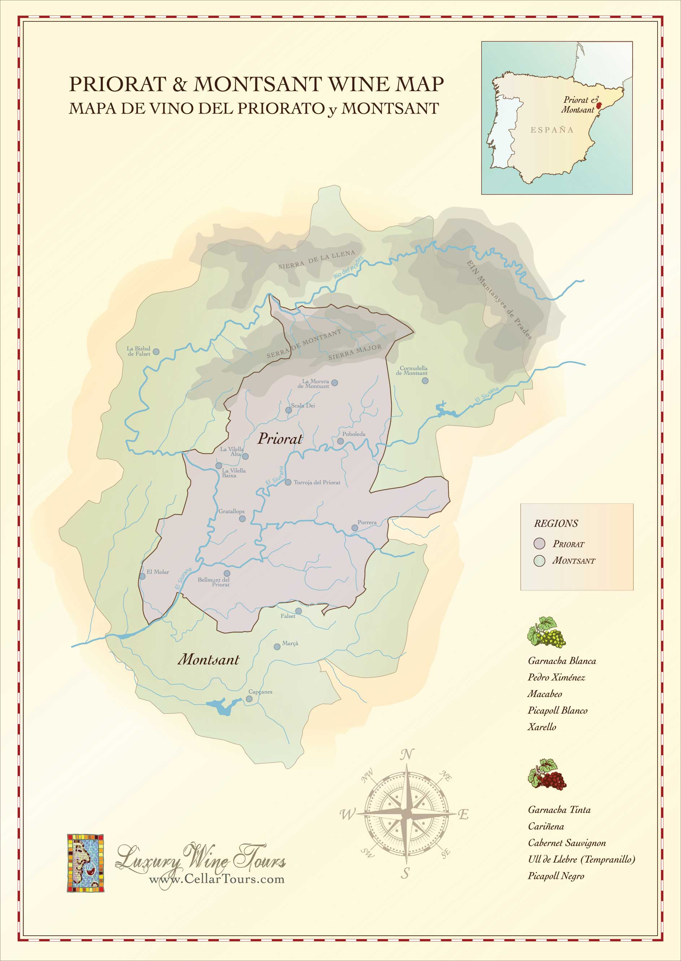
RED
DOQ PRIORAT
The remote rocky hills of the Priorat region are the birthplace of intense and mineral wines. The area is characterized by its unique terroir of black slate and quartz soil known as licorella.

2023 Vall Llach “Embruix” 80
- Merlot, Garnacha, Cariñena, Syrah & Cabernet Sauvignon -
This red wine exhibits an enticing minerality, fine tannins and excellent acidity. Flavors of black fruit, mineral, garrigue, spice, and cocoa linger on the palate along with notes of balsamic, toast, and licorice.

2022 Álvaro Palacios “Les Terrasses" 90
- Garnacha & Cariñena –
This red is round and tender yet has good depth. Cherry and berry flavors mingle with graphite, wild herb and blood orange notes. The structure is unobtrusive, but the wine shows focus and definition.

2022 Llicorella Vins “Clar Del Bosc” 100
- Garnacha, Cariñena, Syrah, & Cabernet Sauvignon –
A rich but expressive nose with plenty of ripe strawberries and cherries with licorice and spices. Juicy and flavorful on the medium to full-bodied palate with plenty of ripe berry fruit. Tight and quite fine-grained.

2023 Vall Llach “Porrera” 130
- Cariñena & Garnacha –
Rich aromas of blackberry, black cherry, anise, and toast. The palate displays enormous concentration, black fruits, and hallmark slate-driven minerality with fine, dusty tannins.

2022 En Números Vermells “Carinyena 1919” 180
- Cariñena –
Extraordinary black-coloured, with excellent complexity and elegance all the way. Beautifully integrated notes of liquorice, spices, berry fruit, and graphite pencil are combined with subtle smoky and tobacco hints.

2023 Llicorella Vins Clar Del Bosc “Les Boves Fresques” 250
- Garnacha –
The nose offers ripe red fruits, Mediterranean herbs, and a delicate mineral and spicy undertone reminiscent of the slate soil. On the palate, it is balanced and silky, with vibrant acidity and lingering minerality.

2024 Álvaro Palacios “Dofí” 250
- Garnacha & Cariñena –
The minerality typical of llicorella soils comes through as crushed stone and graphite, adding a mouth-watering freshness. The long, elegant finish extends this mineral impression with fine persistence.

DOQ PRIORAT CONTINUED…

2022 Clos Mogador 250
- Garnacha, Cariñena, Syrah, & Cabernet Sauvignon –
Upon approaching the nose, it reveals a rich bouquet of dark fruits such as ripe blackberries and plums, perfectly interwoven with subtle citrus hints of orange peel and sweet spices like cinnamon. On the palate, it astonishes with its silky texture and a long finish that imparts freshness, underpinned by well-integrated acidity. It concludes with a delicate floral note reminiscent of rose petals.

2019 Ferrer Bobet “Selecció Especial Vinyes Velles” 290
- Cariñena -
Impressively complex and deep nose with fine roasted spices, tar, lard, cigar box and plenty of mossy black cherries, wild strawberries, and blackberries. Concentrated with a medium- to full-bodied palate and a very flavorful and succulent finish.

2023 Álvaro Palacios “La Baixada” 460
- Garnacha & Cariñena –
A barrel-aged red wine, exhibiting a concentrated and highly tannic profile. On the nose, it features dark fruits such as blackberries and plums, complemented by subtle hints of pine nuts and resin. On the palate, it reveals dusty tannins and a pleasant earthy note. It displays a subtle maturity and a complexity that makes it truly exceptional.

2022 Clos i Terrasses “Clos Erasmus” 500
2021 Clos i Terrasses “Clos Erasmus”, 1.5L 1000
- Garnacha & Syrah -
On the palate the wine is elegant, juicy and powerful. Superfine tannins caress the palate. The structure, density and length are superb. It exudes its charm in the lingering finish, where it continues to show pleasant roasted notes.

2019 Familia Torres “Mas de la Rosa” Vinyes Velles 600
- Cariñena & Garnacha –
Brilliant ruby, with aromas of wild red berries, dried petals, alpine herbs, and a hint of minerality. The palate is vibrant and finely textured, layering strawberry, raspberry, and red cherry with subtle anise and spice, finishing silky and poised with polished tannins.

2023 Álvaro Palacios “Les Aubaguetes” 730
- Garnacha & Cariñena –
This is a scented and elegant wine showing delicate red berry fruit with touches of white pepper, minerals and grapefruit. Firm, medium-bodied and chalky, with a fine thread of tannins. Linear and enveloping in the finish, with rose hips and citrus.

2023 Álvaro Palacios “L’Ermita” 2200
- Garnacha & Cariñena –
On the nose, it reveals aromas of ripe fruits such as cherries and blackberries, accompanied by hints of spices and a wonderful mineral backdrop. On the palate, it is powerful and well-structured, with firm tannins and a long, persistent finish that leaves a pleasant sensation of fruits and spices. Ideal for those seeking a wine with character and depth

DO PENEDÈS
The influence of the sun and the Mediterranean make the Penedès region a privileged territory for winemaking, creating one of the most exciting wine regions in Spain.

2018 Familia Torres "Mas La Plana" 170
- Cabernet Sauvignon -
Toasty on the nose, but more subtle on the palate, an accent for the ripe red currant, cured tobacco, plum sauce and milled pepper notes. A well-knit, medium to full-bodied red, with a tang of orange peel acidity throughout and a mineral-laced, lightly chewy finish.

DOP ABADÍA RETUERTA
Abadía Retuerta is located in the heart of the Duero Valley. Santa Maria de Retuerta Abbey was founded by monks in 1146. In 2022 the winery was certified as Spain’s 23rd Vino de Pago which certifies single estates as Protected Denominations of Origin.

2021 Abadía Retuerta “Selección Especial” 110
- Tempranillo, Cabernet Sauvignon, Syrah, Merlot, Petite Verdot & Garnacha -
Savory and sanguine on the nose, with iron, beef and mineral notes transitioning to plumped black cherry fruit, rich ground coffee and spiced orange peel on the palate. Medium- to full-bodied, with fine, well-meshed tannins and lightly juicy acidity throughout.

2019 Abadía Retuerta “Cuvée Palomar” 200
- Tempranillo, Garnacha, Graciano, & Malbec -
It is characterized by its bold violet color and attractive nose, with aromas of red fruit such as raspberry and sharp strawberry, as well as notes of red liquorice. These flavors are perfectly integrated with the wood, bringing excellence and depth, with an underlying essence of patisserie. On the palate it is highly aromatic, with a delicate and elegant texture, and a very fresh finish.

2017 Abadía Retuerta “Pago Negralada” 220
- Tempranillo -
Deep, rich, and intense nose with hints of violets to the ripe, compact blackberries, chocolate, cigar box and grilled herbs. Juicy and concentrated on the full-bodied palate with fine, dusty tannins.

VINO DE LA TIERRA DE CASTILLA Y LEÓN
Castilla y León produces some of Spain's most respected wines, most notably those of the Ribera del Duero, Toro, Rueda and Bierzo. Wine making in Castilla y León is a very old tradition which goes all the way back to the Romans.

2021 Mauro “Cosecha” 120
- Tempranillo, Syrah, Cabernet Sauvignon, & Graciano -
On the nose, it reveals a complex bouquet of dark fruits, notably blackberries and plums, intertwined with earthy undertones and subtle spice notes. The palate follows through with ripe tannins that provide structure and support, while a refreshing acidity adds balance. Flavors of dark chocolate and hints of oak emerge, showcasing the wine’s careful aging and development.

2022 Mauro “VS” 220
- Tempranillo -
This full-bodied red offers radiant red fruit and spicy nuances on the nose, with equal amplitude from the dense, plushy textured tannins and underscoring minerality. Lively and expressive throughout, with cedar-laced, lingering finish.

DO CAMPO DE BORJA
Campo de Borja is a DO in the autonomía of Aragón. Aragón is nestled against the Pyrenées Mountains, surrounded by the prime wine regions of Catalonia and La Rioja. Viticulture dates back centuries and was closely linked to monastery life. Campo de Borja received DO classification in 1980.

2018 Alto Moncayo “Aquilon” 350
- Garnacha –
A polished red, medium to full-bodied and expressive, this shows fine harmony overall, integrating sculpted, fine-grained tannins and lively acidity with rich and juicy blackberry and boysenberry fruit, dark chocolate shavings, graphite and eucalyptus. Features lingering hints of vanilla, spice and orange peel on the finish.

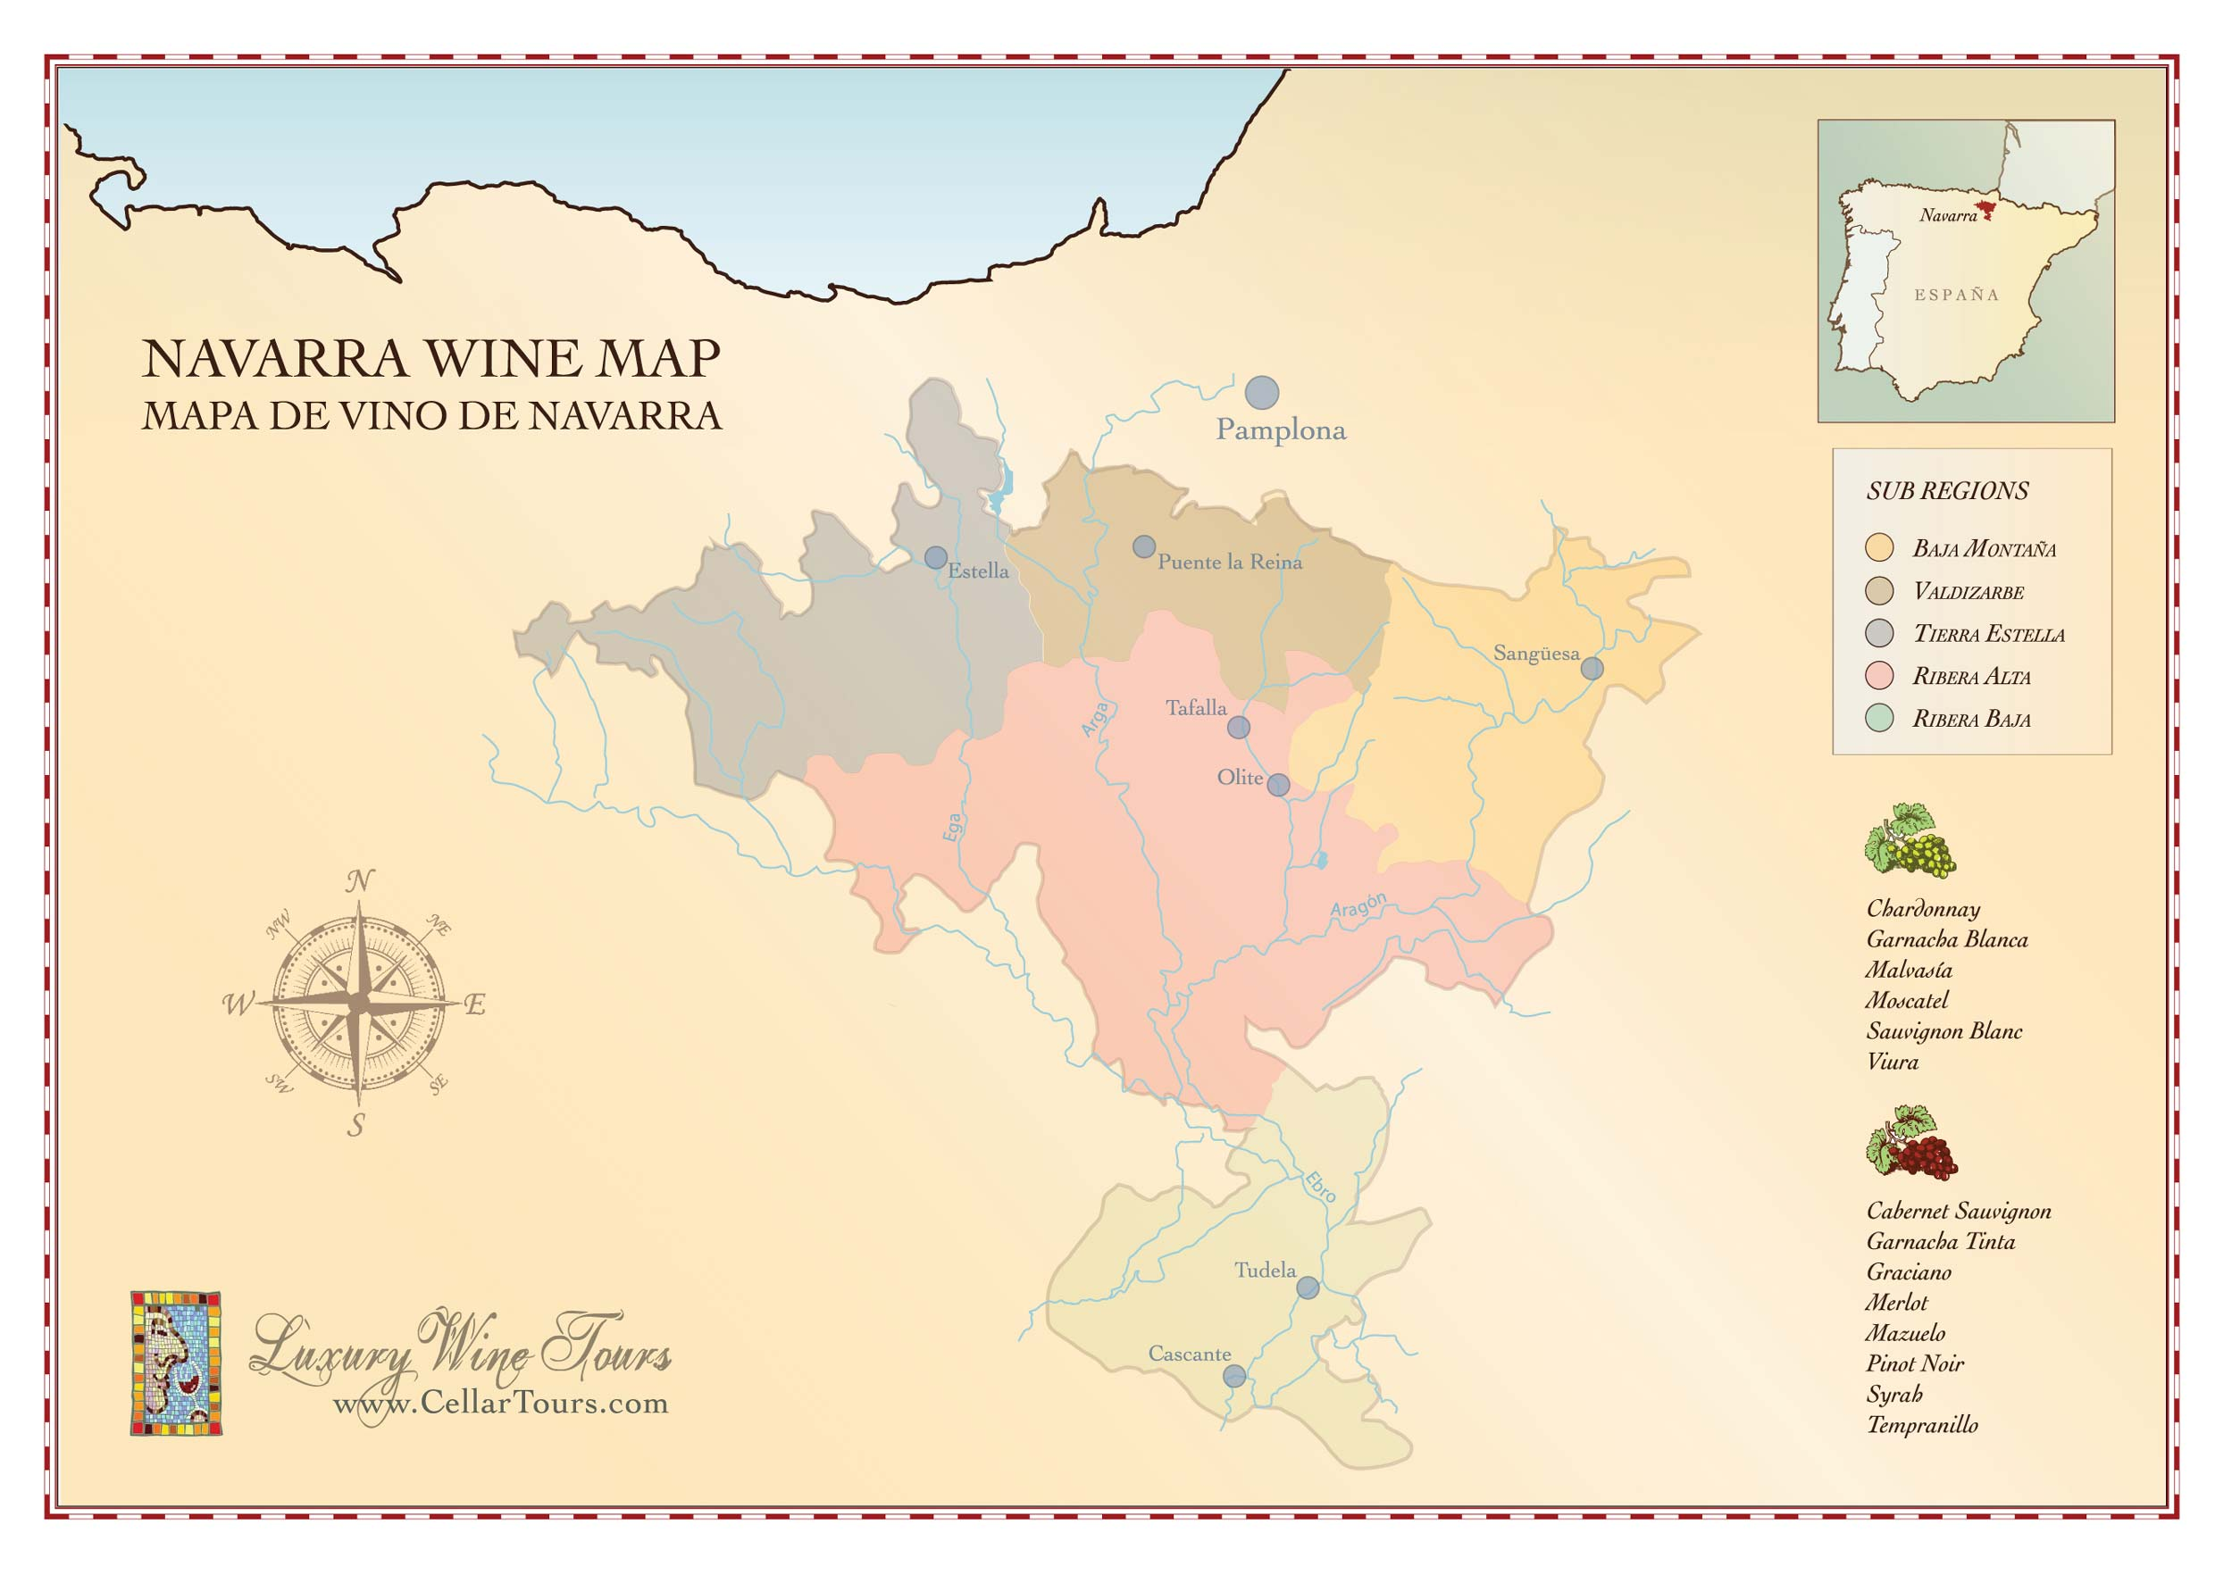
DO JUMILLA
Jumilla is a wine region in the Southeast coast of Spain that produces high-quality wines and has attracted tremendous international attention as of late thanks to the consistency of their rich and ripe style.

2023 El Nido “Clio” 120
- Monastrell & Cabernet Sauvignon -
The color of blackberry preserves, this wine has aromas of Mission fig, ripe summer cherry and anisette. Plush tannins play host to black cherry, raspberry, baking spice and mocha flavors that sail into an enduring butterscotch and milk chocolate finish.

2022 El Nido “La Viña de Corteo” 240
- Syrah -
Dark purple in color, intense and seductive, it is very tasty on the palate, with smoky notes and rich, ripe flavors of blueberries, blackberries and other wild berries.

2023 El Nido 320
- Cabernet Sauvignon & Monastrell -
Deep purple in color. Aromas of berries and vanilla. A ripe, powerful and heady Mediterranean red with well-integrated oak. The juicy palate reveals flavors of sweet spices and dark chocolate. The finish is broad, juicy and impressively long with echoing berry and spice notes.

DO RIBEIRA SACRA

Ribeira Sacra is a winegrowing zone at the heart of Galicia. Its boundaries are marked roughly by the Mino and Sil rivers, both of which flow down from the Cantabrian Mountains en route to the Atlantic Ocean.

2024 Guímaro 70
- Mencía -
On the palate, this red wine delights with its vivacity and lightness, offering a perfectly balanced acidity. The raspberry and cherry motifs recur, augmented by a subtle mineral undertone.

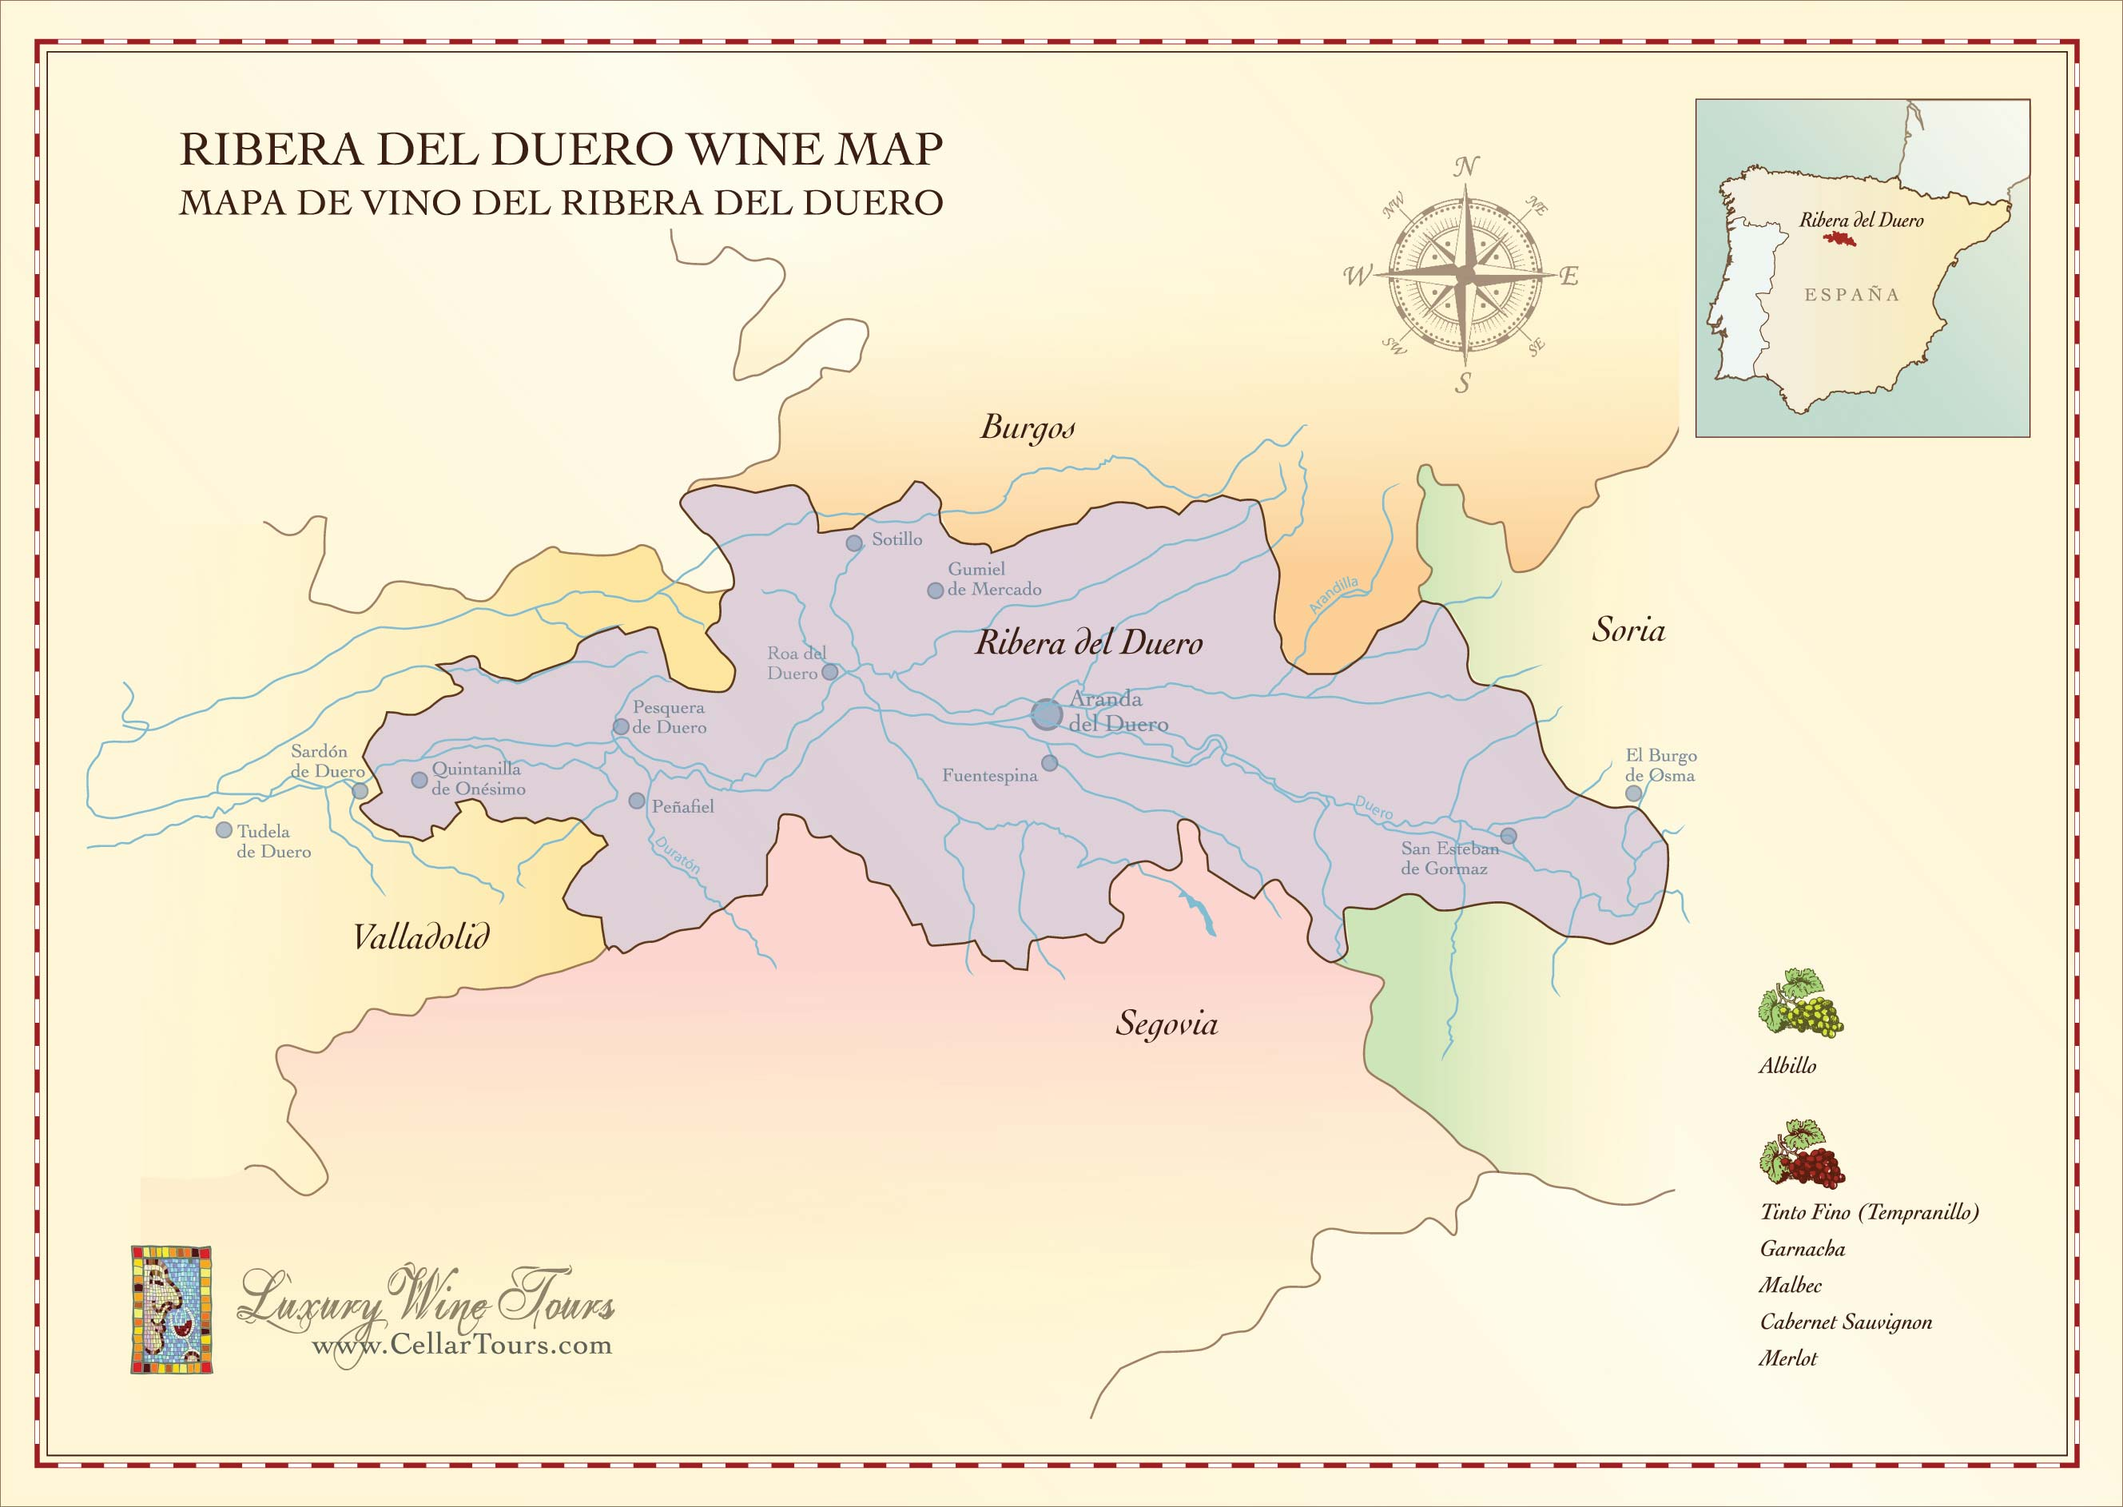

DO RIBERA DEL DUERO

Ribera del Duero is one of the most important wine areas in Castilla y León, Northern Spain. Its reputation is largely thanks to the high - unique - delicate - quality of its red Tempranillo-based wines. The region is characterized by a largely flat, rocky terrain and is centered around the town of Aranda de Duero, although the most famous vineyards surround Peñafiel and Roa de Duero to the West.

2022 La Horra “Corimbo” 90
- Tempranillo-
Deep and spicy with some savory dried herbs to the dark black cherries, cured meat, cocoa powder and spices that extend to a powerful and tight frame of tannins that envelop the fluid black fruit on the palate. Some red fruit, too. Long, juicy and bright finish.

2023 Emilio Moro “Malleolus" 110
- Tempranillo –
An expressive, full-bodied red, with rich flavors of blackberry coulis, black plum reduction, tea leaf, white pepper and mineral riding a plush texture. Modern in style, this is framed by fresh acidity and firm, fine-grained tannins.

2023 La Capilla Vendimia Seleccionada 115
- Tempranillo –
Intense, dark, lively colour. A complex aroma of black fruits, Chinese ink, liquorice, spices and exotic wood. Well-balanced and elegant. Stylish, vibrant, unfussy yet well-structured. A predominant fruity character, with complimentary but not overpowering oak. A very long aftertaste on the palate

2019 Lleiroso “Colección de Familia” Reserva 120
- Tempranillo -
A wine with an intense ruby red color, with aromas of ripe and candied fruit and toasted notes coming from the barrel. On the palate is powerful, expressive and elegant, with a characteristic balsamic touch typical from a zone with minerality always present.

2021 Bosque de Matasnos 125
- Tempranillo, Merlot & Malbec –
This polished red offers plum and blackberry flavors, with notes of espresso, forest floor and mineral. Well-integrated tannins impart a deceptive gentleness, while balsamic acidity keeps this lively.

2023 Pago De Carraovejas 130
2022 Pago De Carraovejas, 1.5L 240
- Tempranillo, Cabernet Sauvignon & Merlot -
A round, supple red, medium- to full-bodied, showing creamed black cherry and boysenberry fruit and hints of toast, vanilla, sage and espresso, all layered over fine, taut tannins. While rich and creamy, this offers fine counterpoints to the lush flavor profile through citrus peel acidity and a minerally base note.

DO RIBERA DEL DUERO CONTINUED…

2021 Pinea del Duero "17" 130
- Tempranillo –
This dense red shows some muscle, featuring dark cherry and red plum fruit, underpinned by loamy earth, cola and spice notes. Details of mocha and wild herb mark the finish, bound by fresh acidity.

2020 Hacienda Monasterio Reserva 150
- Tempranillo & Cabernet Sauvignon -
Intense ruby ​red with bright edges. Complex and mineral aromas with a very mature path, with toasted notes provided by barrel aging. The palate is smooth, giving way to an intense structure and sweet notes. A long and persistent finish, with ripe black fruit.

2019 Ausàs “Interpretación” 180
- Tempranillo-
This wine has a cherry red color and an incredible aromatic purity, with toasted notes, aromas of black berried fruits, and sweet spices. On the palate, it is round and firm, fresh and elegant. The tannins are silky and the acidity is very balanced. The finish is long and recalls fruity notes

2019 Cepa 21 “Malabrigo” 190
- Tempranillo -
This deep-garnet-colored wine has aromas of cassis, cocoa powder, and a touch of baking spice. Luxurious tannins backdrop the blackberry, black cherry, dark chocolate, and black olive flavors, with a hint of dried herbes de Provence that persists into the enduring finish.

2019 Pinea del Duero "Pinea" 280
- Tempranillo –
Kirsch, currant and blueberry flavors mingle over loamy earth and bramble notes in this rich red. Firm tannins and balsamic acidity support the plush texture.

2023 Dominio de Pingus “Flor de Pingus” 285
- Tempranillo –
A concentrated red wine with aromas of ripe red fruit accompanied by expressive notes of violet flowers and hints of chocolate. On the palate, it is elegant, vibrant, and powerful. The wine has present and granulated tannins, integrated acidity, and a refined finish with a touch of bitterness.

2021 Pago de Carraovejas “El Anejón” 300
- Tempranillo, Merlot & Cabernet Sauvignon –
A precise, polished Ribera del Duero that delivers not only structure but also refinement with delineated aromas and flavors. Dusty cocoa powder and dark spices are knit to the red and blue berries. Firm and juicy on the palate with polished tannins and a juicy, long finish.

DO RIBERA DEL DUERO CONTINUED…

2023 Aalto P.S. 300
- Tempranillo –
Reddish-purple color. The nose reveals black fruit, spices, and soft notes of fine wood. On the palate, it offers a fresh sensation with good structure and volume, and a subtle, lingering finish

2022 Emilio Moro “Malleolus de Sanchomartin" 375
- Tempranillo –
Sleek and tightly trimmed up front, this full-bodied red is rich, with a lovely plushness on the palate as this unfolds and opens. Features fruit notes of black raspberry and black currant that are ripe yet fresh, underscored by a rich vein of smoky mineral and loamy earth. Reveals accents of eucalyptus and citrus peel, spice box and rose hip that linger on the creamy finish.

2021 Pago de Carraovejas “Cuesta de las Lliebres” 430
- Tempranillo –
Expect the fine integration of high-grade wood, showing notes of peppermint, spices, truffles, dark chocolate, grilled herbs and dark cherry and blackberry fruit. Full-bodied and resolved, with seamless, powdery tannins and a juicy, tightly wound finish. Even, polished and effortless for such remarkable balance. It has a high level of concentration, with plush, integrated oak.

2015 Dominio del Águila “Peñas Aladas” Gran Reserva 700
- Tempranillo Cariñena, Bruñal, Bobal, Albillo, & Garnacha –
Fragrant aromas of violets mix with wild berries, blackcurrant, plum, and subtle spices. Full-bodied and energetic with high concentration, offering a touch of rustic charm balanced by elegance.

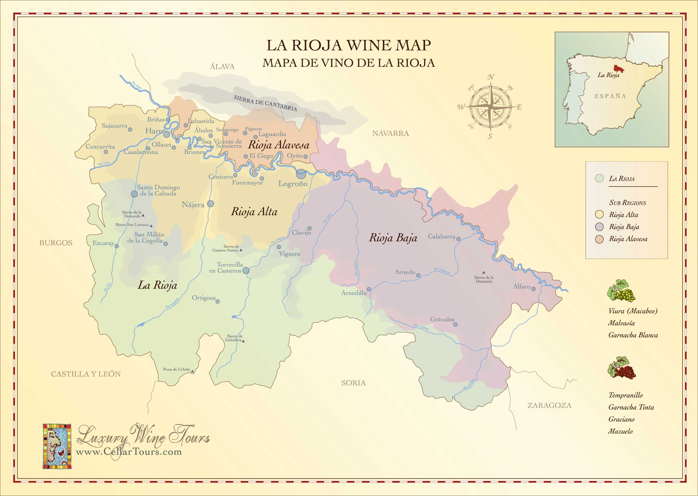

DOCa RIOJA

Along the Ebro River, the region is practically divided in three. Rioja Alta which has a great deal of rainfall and a mild climate. Rioja Baja which is hotter and more arid.
Last but not least the Rioja Alavesa home to some of Spain’s finest red wines.

2015 R. López de Heredia Viña Tondonia, “Viña Bosconia” Reserva 90
- Tempranillo, Garnacha, Graciano & Mazuelo -
Savory plums, berries, orange peel and iron. Some dried spices too. Quite firm and fine-grained, this has medium to full body and a finish that’s long, savory and not heavy. Tannins are still a little tight.

2018 C.V.N.E. “Contino” Reserva 100
- Tempranillo, Graciano, Mazuelo & Garnacha -
This sleek red offers raspberry and plum flavors flanked with anise, orange zest and mineral notes that are focused and fresh, followed by a smooth finish.

2024 Diego Magaña “Anza” 100
- Tempranillo, Viura, Malvasia, Graciano & Mazuelo-
Chalk, vibrant berries, hibiscus and wet stones. Rich in red cherry fruit and plums, but fresh, with a medium to full body and tight, fine-grained tannins. Long and structured.

2017 La Rioja Alta, “Viña Arana” Gran Reserva 120
- Tempranillo & Graciano -
Deep, dark crimson color with an elegant garnet robe. Balanced alcohol and acidity on the palate, with polished, supple tannins that contribute to its refined structure and fresh, delicate mouthfeel, as well as a long, lingering finish.

2019 Martínez Corta “Cepas Antiguas” 135
- Tempranillo -
Roasted plum, berry and clove aromas set up a tough, saucy palate with pronounced tannins. Tomato, spiced plum and cinnamon flavors are a bit raw, as is a lean finish.

2014 R. López de Heredia Viña Tondonia, “Viña Tondonia” Reserva 140
- Tempranillo, Garnacha, Graciano & Mazuelo -
This elegant red is fine and creamy on the palate, with notes of sun-dried cherry, iron, spiced orange peel, graphite and mocha that slowly unfurl. A bit high-toned on the nose as well as loaded with mineral aromas. Muscular tannins are deftly integrated, while savory dried mint and eucalyptus notes play on the lasting finish.

2020 Beronia “Vareia Beronia” Viñedo Singular 150
- Tempranillo -
A full-bodied, balanced, and well-structured wine with notes of ripe blackberries, plums, blackcurrants, dried herbs, vanilla, and baking spices.

DOCa RIOJA CONTINUED…

2020 Roda “Roda I” Reserva 190
- Tempranillo & Graciano -
Very intense and deep, with very well integrated and high-quality oak. Ripe and fresh black fruits and plum predominate with chocolate notes and hints of tobacco leaf. It has a mineral character that highlights the smell of the earth, mixed with aromas of aromatic plants. Voluminous, full, and broad with very fine and noble tannins.

2018 C.V.N.E. Contino “Viña del Olivo” 250
- Tempranillo, Graciano, & Mazuelo -
Dried flowers, violet, tea, thyme and hibiscus, with a touch of plum. The palate is medium- to full-bodied, with detailed fruit, fleshy but well restrained. Freshness and linearity bring cohesion, making the wine both balanced and highly appealing. Long and elegant, with a subtle spice note on the finish.

2020 Benjamín Romeo Contador “Alma” 260
- Tempranillo & Garnacha -
Balsamic aromas and aromatic herbs appear on the nose. The oak appears very quickly, but then evolves until it disappears and becomes incense and sandalwood. This is followed by aromas of blueberries, lavender and iodine. The palate is very fine, with polished tannins.

2020 Herederos del Marqués de Riscal “Baron de Chirel” 290
- Tempranillo, & Cabernet Sauvignon -
A powerful, dense, very rich attack. It combines sensations of volume, structure and richness with a silky texture which never ends. Lively tannins, discernible but ripe and which will become more polished with time. Very long and persistent, elegant with magnificent acidity which augurs well for great ageing. The fruit is present, and also the blue flowers

2019 Herederos del Marqués de Riscal “Frank Gehry Selection” 500
- Tempranillo -
The palate is structured, with polished tannins, a warm mouthfeel, and a long, oaky finish. Flavors include black currant, loamy earth, dried mint, and dark chocolate.

2021 Roda “Cirsion” 620
- Tempranillo & Graciano -
Such a deep, polished wine with aromas of cocoa powder, violet extract, iodine, fresh blackberries, minerals, spices and black pepper. Super crafty tannins on the palate with concentrated fruit. Full-bodied and juicy, rounded by an iron fist of filigreed, melted tannins. Extremely long, plush and voluptuous, but not heavy.

DOCa RIOJA CONTINUED…

BODEGAS MARQUÉS DE MURRIETA
CASTILLO YGAY

1989 “Castillo Ygay” Gran Reserva Especial 1500
- Tempranillo, Mazuelo, Garnacha, & Graciano -
1995 “Castillo Ygay” Gran Reserva Especial 1.5L 2000
- Tempranillo, Mazuelo, Garnacha, & Graciano -
2001 “Castillo Ygay” Gran Reserva Especial 800
- Tempranillo, & Mazuelo -
2011 “Castillo Ygay” Gran Reserva Especial 400
- Tempranillo, & Mazuelo -

Castillo de Ygay Gran Reserva Especial is considered the most prestigious red wine from Marqués de Murrieta, one of the most traditional and renowned wineries in Rioja. This wine is exclusively made as Gran Reserva in the vintages considered by the winery to be of excellent quality.

Castillo Ygay is always made from grapes sourced from La Plana, a 40-hectare (98-acre) vineyard, planted in 1950 and located at 485 meters altitude, the highest area of Ygay Estate; the 300-hectare estate surrounding the winery in Rioja Alta.

