Beer On Draft
Kirin Ichiban – Pale Lager – 5% - Japan 6
Troegs – Dream Weaver Wheat - 7.5% - PA 8
Rotating Wheat 7
Rotating IPA 7

Back to the Basics
Bud Light - 5% - MO 7
Stella Artois - 5% - Belgium 6
Kirin Light - 3.2% - Japan 6
Busch Light - 4.1% - MO 5
Estrella Jalisco - 4.5% - Mexico 6
Natty Daddy - 8% 5

oh you fancy huh
Landshark Lager - 4.6% - FL 6
Bluepoint Toasted Lager - 5.5% - NY 7
Bluepoimt Toasted Lager - 5.7% - NY 7
Devil’s Backbone Vienna Lager - 5.2% - VA 6
Devil’s Backbone 16 Point IPA - 9.1% - VA 12
Goose Island 312 IPA - 5.9% - IL 7
Goose Island 312 Shandy - 4.2% - IL 6
Bold Rock Apple Cider - 4.7% - NC 6

Flavor Bubbles
Kona Seltzer - 5% - HI 6
Nutrl Seltzer - 4.5% - WI 7
High Noon - 4.5% - CA 7
Akashi High Ball - Japan 8
Akashi High Ball Yuzu 8

The Familiar
Old Fashioned 10
Bourbon, Luxardo, Angostura

Cosmopolitan 10
Vodka, Triple Sec, Cranberry Juice, Lime

Paloma 10
Tequila, Grapefruit, Agave, Lime

Gin Rickey 10
Gin, Lime, Soda

Build Your Own Mule 10
Pick your own spirit, Lime, Bitters, Ginger Beer

Mojito 10
Rum, Lime, Agave, Soda

Hatoba Cocktails

Tokyo Mule 13
Vodka, Lime Juice, Cucumber Juice, Ginger Beer

Fizzy Smalls 13
Gin, Yuzu, Agave, Tonic, Club Soda

Japaneses Slipper 13
Midori, Cointreau, lemon, cherry

Just Say Thank You 14
Shochu, Sake, Lychee Liqueur, Simple, Lime

OyaBun 14
Nikka Whiskey, Amaretto, Bitters

20oz Big Island Ice Tea 18
Vodka, Gin, Rum, Tequila, Triple Sec, Hawaiian Iced Tea, Agave, Lemon, Lime

Seasonal Cocktails

Vanilla Grapefruit Margarita 12
Tequila, Triple Sec, Grapefruit, Vanilla Bean, Lime

Apple Cider Whiskey Sour 12
Whiskey, Spiced Apple Cider, Lemon, Agave, Five Spice Bitters, Cherry

Cranberry Basil Gin Rickey 12
Gin, Cranberry Juice, Basil Syrup, Lime, Club Soda

Frozen
Take Away My Pain, Killer…. 12
Rum, Kraken, Coconut, Pineapple, Orange, Lime

Rotating Frozen 12
Ask for details!

Happy Hour

Wed-Fri 5pm-7pm
Sat-Sun Open til Close
(Drinks Only on Sat-Sun HH)

$4 Busch Light

$4 Landshark

$5 Goose Island Shandy

$5 Rotating Draft

$6 Rail Drinks

$8 Frozens

$8 25oz Natty Daddy’s

$9 Rotating Cocktail

$25 Bartender’s Choice Buckets

Please note there is now a 20% service
charge, which includes tip. This helps us
to better support all of our hard-working
employees. Thank you for your support.
If you would like to have this adjusted to your comfort level please ask for the manager on duty.
- DAIKAYA GROUP

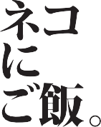

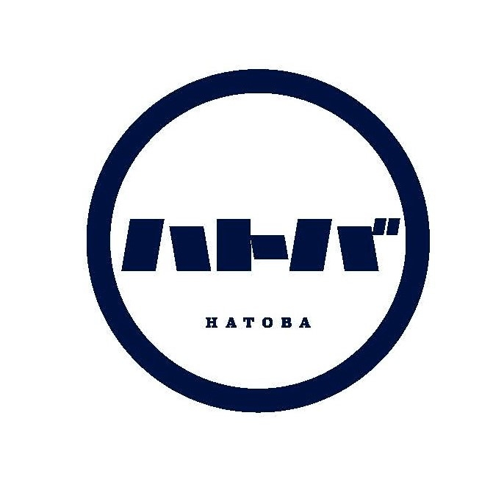

HATOBA DRINK MENU

