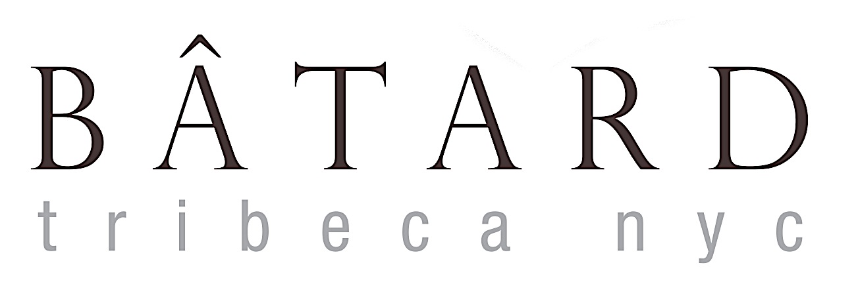

WELCOME BACK TO BÂTARD
gazpacho sun gold tomatoes, crab salad, fresh basil 17

OYSTERS ON THE HALF SHELL black pepper mignonette, lemon MP

Crudite seasonal vegetables, dill yogurt, anchovy vinaigrette, herb coulis 18

LEBERWURST duck liver, sauternes, warm mushroom brioche 23

Green market salad radicchio, baby gem, garbanzos, white balsamic vinaigrette 17

BLUEfin TUNA daikon radish, baby bok choy, citrus vinaigrette 25

CELERY ROOT TARTARE classic flavors, cognac, aged parmesan 19

CRISPY OCTOPUS white bean ragu, meyer lemon, agrodolce gremolata 26

AGNOLOTTI patty pan squash, zucchini blossom, pea pesto 29

Saffron Tagliatelle little neck clams, mussels, prawns, tarragon 35

WIENER SCHNITZEL fingerling potato salad, dill cucumber, lemon, lingonberries 38

amish chicken artichoke barigoule, sunchoke, smoked chicken jus 36

seared branzino sweet corn succotash, roasted red peppers, charred broccolini 38

Wagyu beef burger house made brioche, cheddar, spicy mayo, pommes frites 27

BRANDT BEEF TENDERLOIN bone marrow crust, shallot tarte tatin, sauce bourguignonne 59

WILD MUSHROOMS sherry vinegar, parsley 10

POMMES PUREE fingerling potatoes, beurremont butter 10

cHARRED BROCCOLINI lemon vinaigrette 10

VIENNESE POTATO SALAD dijon mustard, shallots, white wine vinegar 10

BÂTARD CANDY BAR chocolate hazelnut fudge, caramel, feuilletine crunch 14

blueberry OLIVE OIL CAKE summer corn, blueberry compote, flaxseed streusel 14

Apple Tart camembert cheese, apple cider surette 14

Pâte à Choux bartlett pear, sage butter crumble, quark ice cream 14

executive chef markus glocker
239 west broadway new york, ny 10013 212-219-2777
www.batardtribeca.com instagram: batardny
*Consuming raw or undercooked meats, poultry, seafood, shellfish, or eggs may increase your risk of foodborne illness.

S E A S O N A L C O C K T A I L S

GINGER DAISY buenbicho mezcal, dry curaçao, giffard ginger liqueur, lime 14
GiN Paloma greenhook gin, grapefruit, lime, luxardo liqueur 14
OL’ DIRTY BÂTARD jim beam rye, punt e mes, cocchi rosa, mole bitters 15

WINES BY THE GLASS
sparkling
Crémant de Bourgogne Rosé victorine de chastenay, burgundy nv 15

white
Bourgogne Aligoté georges lignier, burgundy 2015 14
Grüner Veltliner ‘Kogl’ forstreiter, kremstal 2018 17
Chablis ‘Côte de Bréchain’ domaine testut, burgundy 2018 20
PERAND-VERGELESSES PREMIER CRU ‘CLOS BERTHET’ dubreuil-fontaine, burgundy 2014 24

rose
Côteaux varois domaine de cala, provence, 2019 15

red
Côtes du Rhône domaine les aphillanthes ‘le cros,’ rhône 2016 12
Beaujolais-Villages guy breton ‘cuvée marylou,’ burgundy 2017 14
BOURGOGNE ROUGE cyrot-buthiau, burgundy 2017 17
SAVIGNY-LÈS-BEAUNE PREMIER CRU ‘SERPENTIÈRES’ michel gay, burgundy 2014 24

B E E R & C I D E R

CENTENNIAL IPA founders, michigan 7
KÖLSCH schafly, missouri 7
RARE VOS AMBER ALE ommegang, new york 8
HELLES LAGER stiegl, austria 8
DRY CIDER aval, france 13

wine director jason jacobeit

BOTTLED WINE
Seasonal Short List

HALF-BOTTLES

white
Mercurey ‘Clos Rochette’ domaine faiveley, burgundy 2017 38
Meursault Premier Cru ‘Genevriėres’ bouchard pėre et fils, burgundy 2017 120

red
Aloxe-Corton edmond cornu, burgundy 2013 52
Nuits-St. Georges henri gouges, burgundy 2017 80

FULL BOTTLES

sparkling
Crémant de Bourgogne Rosé victorine de chastenay, burgundy nv 48
Champagne moutard ‘grand cuvée nv 72

white
Bourgogne Aligoté georges lignier, burgundy 2015 36
Grüner Veltliner ‘Kogl’ forstreiter, kremstal 2018 40
Bourgogne Aligoté domaine goisot, burgundy 2018 42
Chablis ‘Côte de Bréchain’ domaine testut, burgundy 2018 54
Chardonnay ‘Bien Nacido Block UU’ foxen, santa barbara 2016 72
St.-Romain christophe buisson, burgundy 2014 74
Chablis Premier Cru ‘Vaucoupin’ jean-pierre grossot, burgundy 2017 84
Pernand-Vergelesses follin-arbelet, burgundy 2014 96
St.-Aubin Premier Cru ‘Pintangerets’ paul pillot, burgundy 2017 120
Chassagne-Montrachet Premier Cru ‘Vergers’ f&l pillot, burgundy 2014 135
Meursault Premier Cru ‘Charmes’ bouzereau-gruėre, burgundy 2016 195

wine director jason jacobeit

rose
Côteaux varois domaine de cala, provence, 2019 60

red
Côtes du Rhône domaine les aphillanthes ‘le cros,’ rhône 2016 40
Beaujolais-Villages guy breton ‘cuvée marylou,’ burgundy 2017 42
Terrasses du Larzac mas des chimėres, languedoc 2016 46
Hautes Côtes de Beaune chanson, burgundy 2014 48
Maranges david moreau, burgundy 2014 54
Mercurey ‘Les Mauvarennes’ domaine faiveley, burgundy 2017 62
Bourgogne Passetoutgrains robert chevillon, burgundy 2016 64
Zinfandel ridge ‘3 valleys,’ sonoma 2017 66
St.-Romain alain gras, burgundy 2015 68
Savigny-Lės-Beaune ‘LES GOUDELETTES’ antonin guyon, burgundy 2014 70
Savigny-Lės-Beaune Premier Cru ‘LES VERGELESSES’ michel gay, burgundy 2014 84
Listrac-Médoc château clarke, bordeaux 2011 94
Santenay Premier Cru ‘Clos Tavannes’ pousse d’or, burgundy 2013 100
Gevrey-Chambertin ‘Clos des Chezeaux’ dmne. des chezeaux, burgundy 2017 102

wine director jason jacobeit

